Task 1Introduction



**Welcome to Advent of Cyber 2022**

Get started with Cyber Security in 24 days! Learn the basics and complete a new, beginner-friendly security exercise every day leading up to Christmas. *It’s an advent calendar but with security challenges instead of chocolate!*

**Main Prizes**

We have over **$40,000** worth of prizes!

In this event, points don’t matter, but the number of questions you answer does! For each question you get correct, you get a raffle ticket. We will randomly choose the winners on the 28th of December using everyone’s raffle tickets. The more questions you answer, the more chances you have of winning. Here are the prizes up for grabs:

|  |  |
| --- | --- |
| 6x Offensive Security Learn One Subscriptions ($12000) 1x TryHackMe will donate to your favourite charity ($2000) [5x Raspberry Pi 400 ($580)](https://www.raspberrypi.com/products/raspberry-pi-400/) [10x Airpods 2nd Gen Pro ($2500)](https://www.apple.com/uk/shop/product/MQD83ZM/A/airpods-pro) [6x DJI Drone ($3000)](https://www.currys.co.uk/products/dji-mini-2-drone-with-controller-space-grey-10216745.html) [10x GoPro ($3500)](https://gopro.com/en/us/shop/cameras/hero11-black/CHDHX-111-master.html) [10x CompTIA Security+ Vouchers ($2700)](https://uk-store.comptia.org/comptia-security-plus-exam-voucher/p/SEC-601-TSTV-20-C) | [4x Remarkable 2 ($1200)](https://remarkable.com/store/remarkable-2) [10x Flipper Zero ($2100)](https://flipperzero.one/) [12x ASUS ZenBook 14 8GB RAM, 512GB SSD, Intel i5 ($8400)](https://www.amazon.co.uk/ASUS-Zenbook-UX425EA-i5-1135G7-Keyboard/dp/B09KZMCMWS) [10x Hak5 WiFi Pineapple ($1200)](https://shop.hak5.org/products/wifi-pineapple?variant=81044992) [10x Hak5 Rubber Ducky ($600)](https://shop.hak5.org/products/usb-rubber-ducky?variant=353378649) [15x TryHackMe Monthly Subscriptions ($150)](https://tryhackme.com/why-subscribe) [5x $20 TryHackMe Swag Vouchers ($100)](https://store.tryhackme.com/) |

*Total Prize Pool Value: ~****$40,100***

***For Learn One Subscriptions, winners will be able to select their Offensive Security course.***

View Giveaway Terms & Conditions

**Daily Prizes**

Also, every day you complete a question, you get entered into another prize draw for the chance to win a mini-prize. Each day you can win one of two prizes: a 1-month TryHackMe subscription voucher or £15 swag voucher.

The prize winners for each day will be announced on Mondays on Twitter, and they will be contacted via email.

**How to qualify**

To qualify for prizes, you must answer questions in Advent of Cyber 2022 challenges, starting with Day 1 (Task 6 of this room). Only questions answered in the Advent of Cyber 2022 room will qualify you for the raffle.

For the main prize pool, it does not matter when you complete tasks, only that you complete them before December 28th, 2022. To qualify for daily prizes, you must complete tasks on their release days (for example, complete Day 8 on December 8th).

**Certificate**

Finally, if you complete every task in the event, you will earn a certificate of completion! Make sure your name is set in [your profile](https://tryhackme.com/profile).

View Sample Certificate

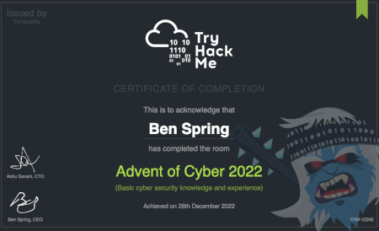

**Videos Featuring**Each task released has a supporting video walkthrough. You can expect to see some of your favourite cyber security video creators and streamers guiding you through the challenges! This year we are featuring John Hammond, Cybersecurity Meg, Husky Hacks, SecurityNinja, Neal Bridges, InsiderPHD, and more!

**Topics Include**Topics that will be covered in the event are:

Red Teaming Secure Coding Web Vulnerabilities Blue Teaming IoT Hacking

Answer the questions below

Read the above and check out the prizes!

Top of Form

Correct Answer

Bottom of Form

Task 2Short Tutorial & Rules



Top of Form

Bottom of Form

Task 3Our Socials

|  |  |  |  |
| --- | --- | --- | --- |
|  |  |  |  |

|  |  |  |
| --- | --- | --- |
|  |  |  |

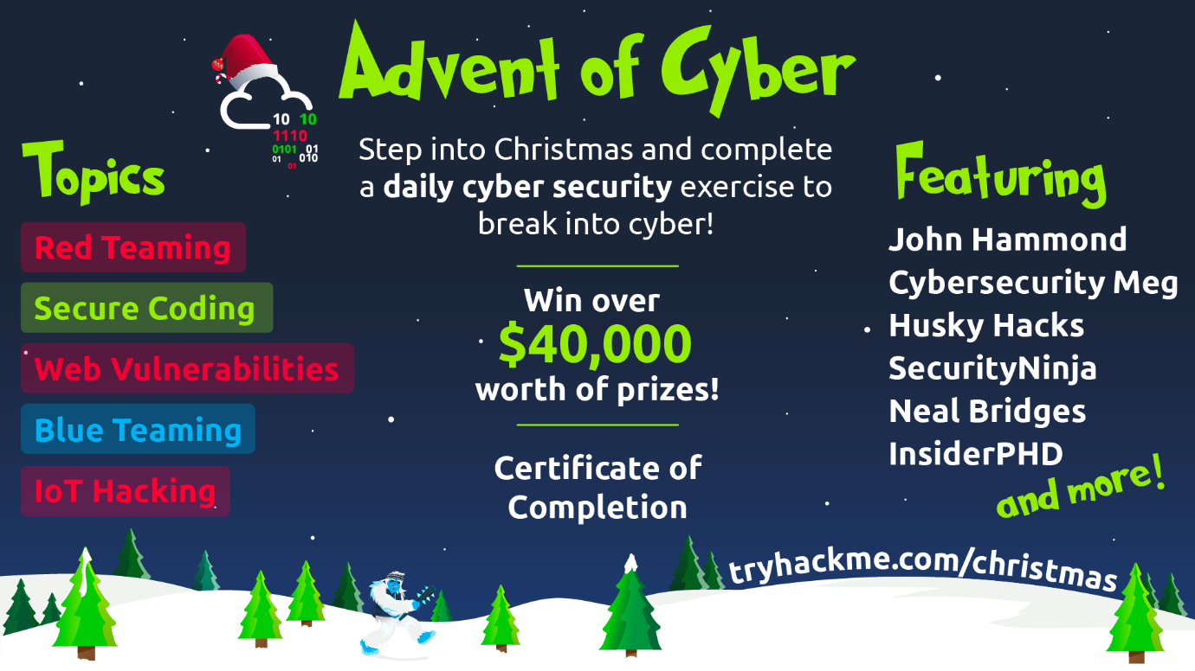

Top of Form

Bottom of Form

Top of Form

Bottom of Form

Top of Form

Bottom of Form

Top of Form

Bottom of Form

Top of Form

Bottom of Form

Top of Form

Bottom of Form

Top of Form

Bottom of Form

Task 4Subscribing, TryHackMe for Business & Christmas Swag!

[](https://tryhackme.com/why-subscribe)

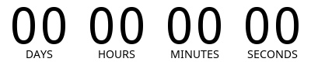

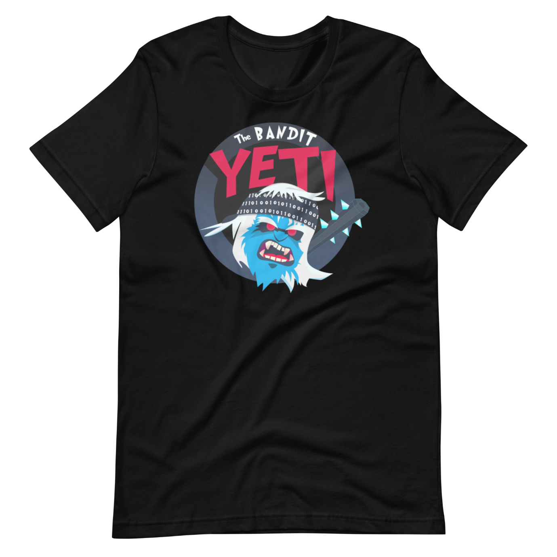

Top of Form

Bottom of Form

Task 5Nightmare Before Elfmas - The Story

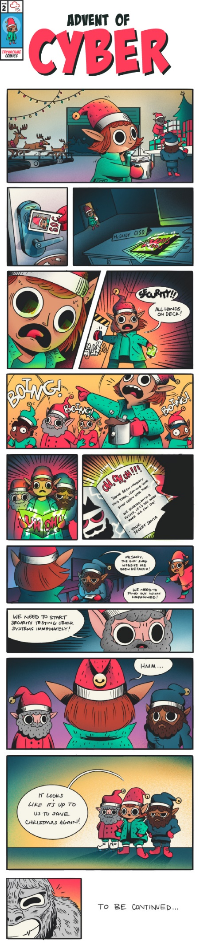

Top of Form

Bottom of Form

Task 6[Day 1] Frameworks Someone's coming to town!

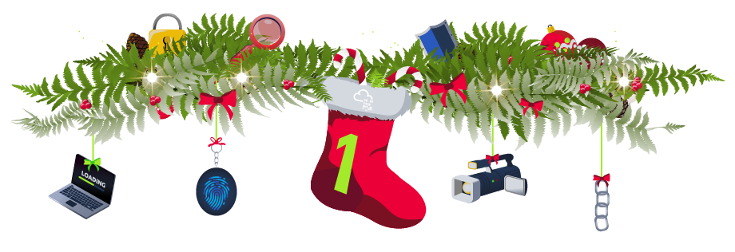

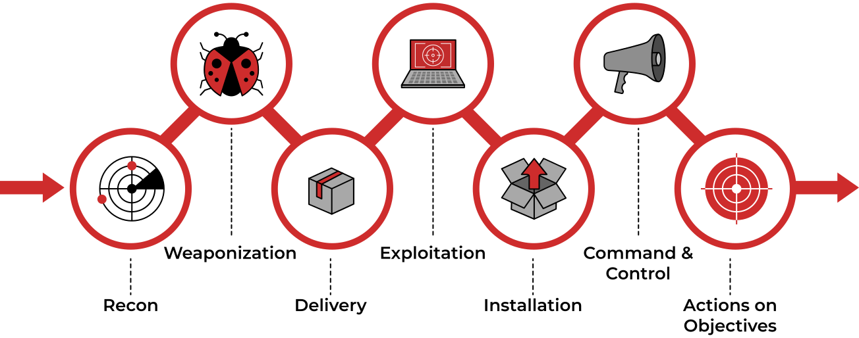

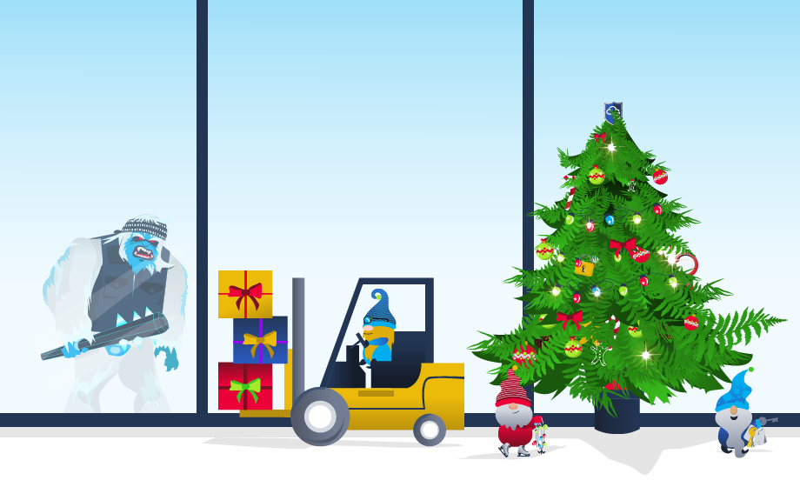

* 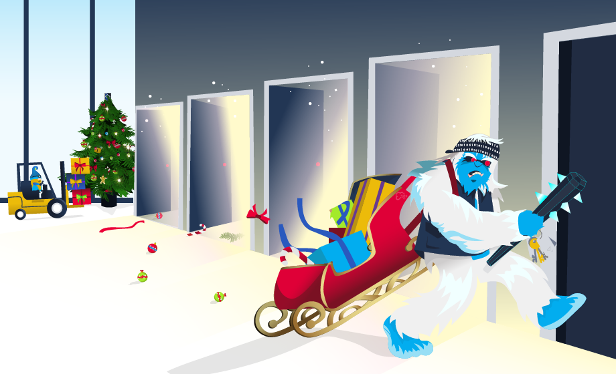



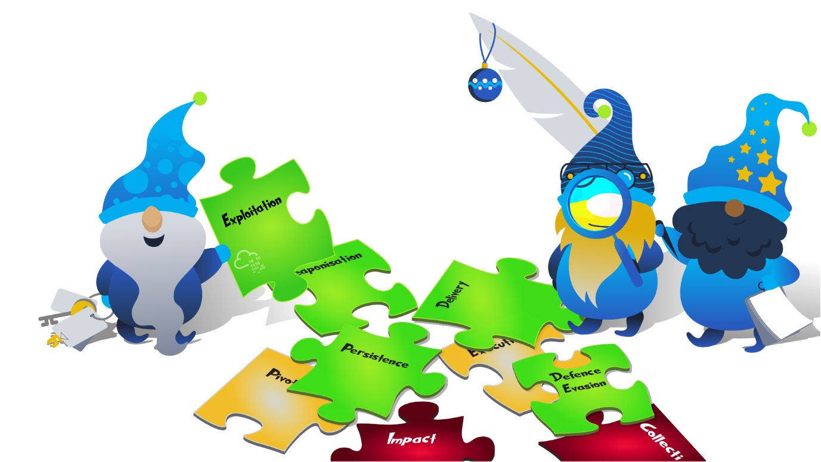

Top of Form

Bottom of Form

Top of Form

Bottom of Form

Top of Form

Bottom of Form

Task 7[Day 2] Log Analysis Santa's Naughty & Nice Log





|  |  |
| --- | --- |
|  |  |
|  |  |
|  |  |
|  |  |
|  |  |
|  |  |





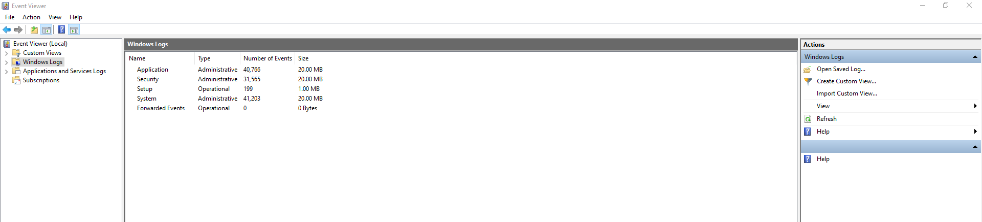

|  |  |  |
| --- | --- | --- |
|  |  |  |
|  |  |  |
|  |  |  |
|  |  |  |
|  |  |  |

|  |  |  |  |
| --- | --- | --- | --- |
|  |  |  |  |
|  |  |  |  |
|  |  |  |  |
|  |  |  |  |
|  |  |  |  |

|  |  |
| --- | --- |
|  |  |
|  |  |
|  |  |
|  |  |



|  |  |  |
| --- | --- | --- |
|  |  |  |
|  |  |  |
|  |  |  |
|  |  |  |

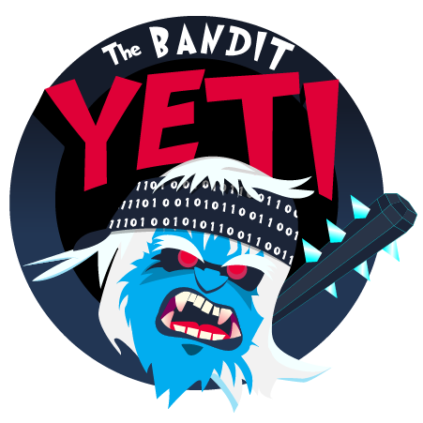

Top of Form

Bottom of Form

Top of Form

Bottom of Form

Top of Form

Bottom of Form

Top of Form

Bottom of Form

Top of Form

Bottom of Form

Top of Form

Bottom of Form

Top of Form

Bottom of Form

Top of Form

Bottom of Form

Top of Form

Bottom of Form

Task 8[Day 3] OSINT Nothing escapes detective McRed





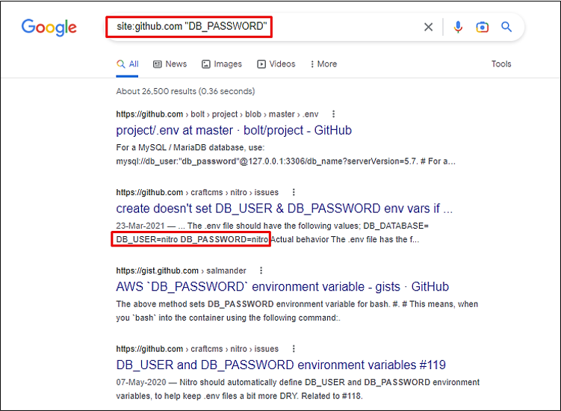

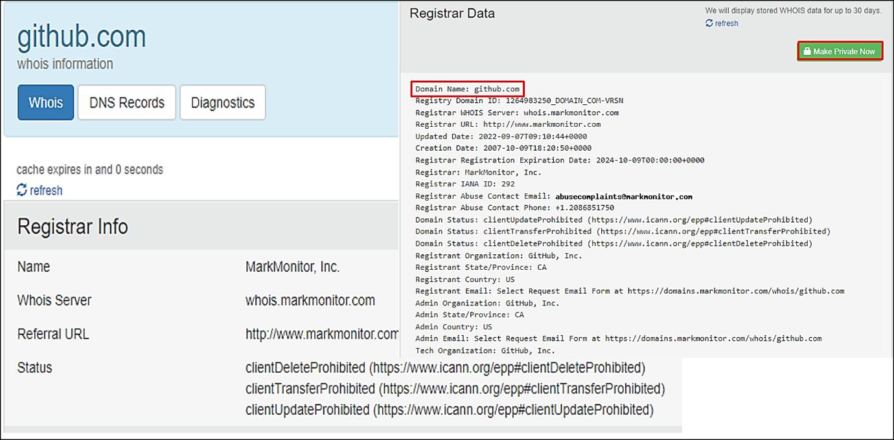

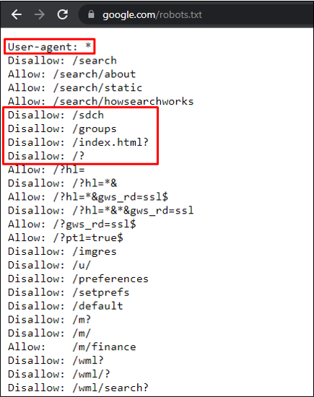

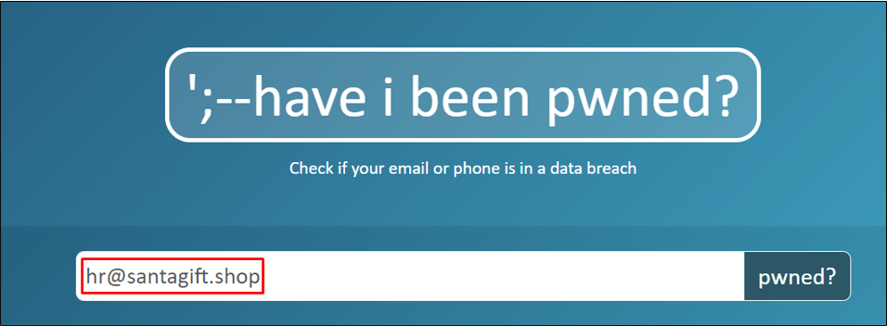



Top of Form

Bottom of Form

Top of Form

Bottom of Form

Top of Form

Bottom of Form

Top of Form

Bottom of Form

Top of Form

Bottom of Form

Top of Form

Bottom of Form

Task 9[Day 4] Scanning Scanning through the snow

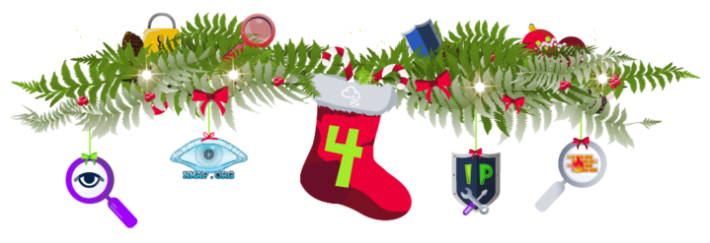

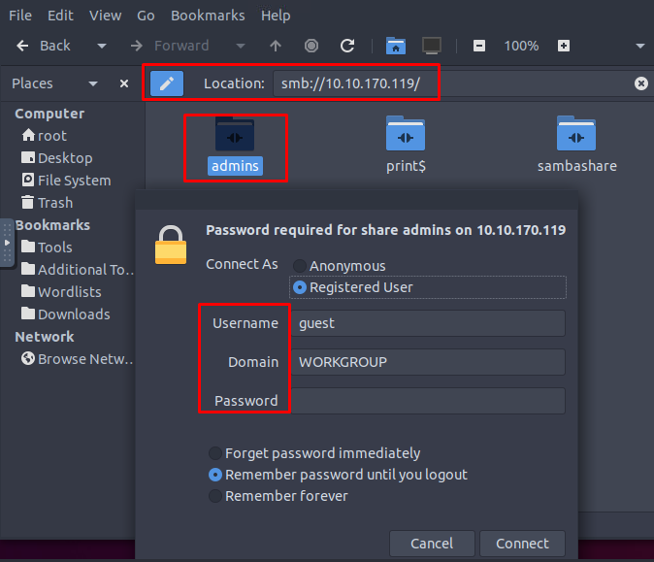

Top of Form

Bottom of Form

Top of Form

Bottom of Form

Top of Form

Bottom of Form

Top of Form

Bottom of Form

Top of Form

Bottom of Form

Task 10[Day 5] Brute-Forcing He knows when you're awake

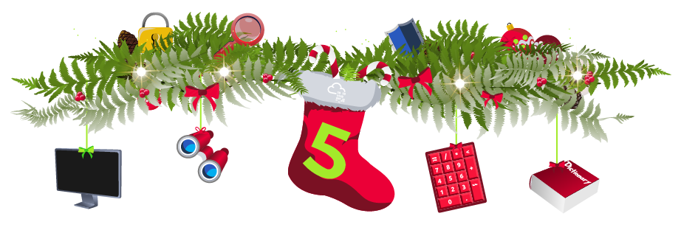



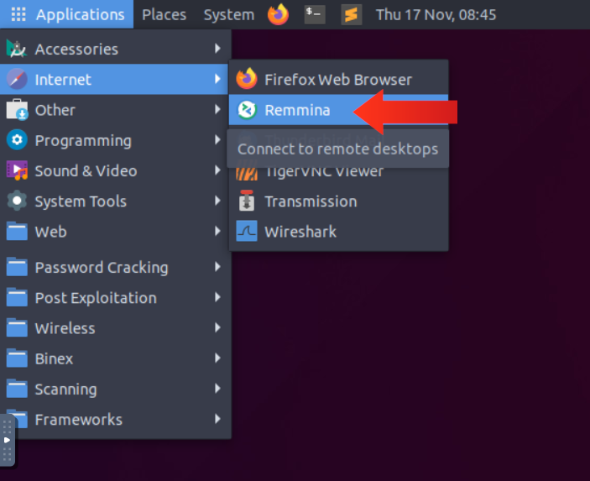

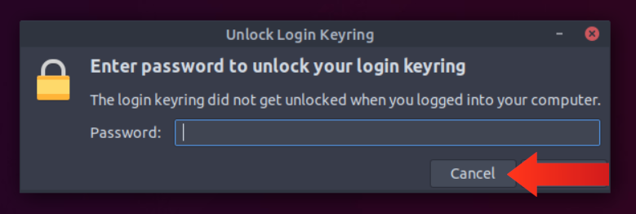

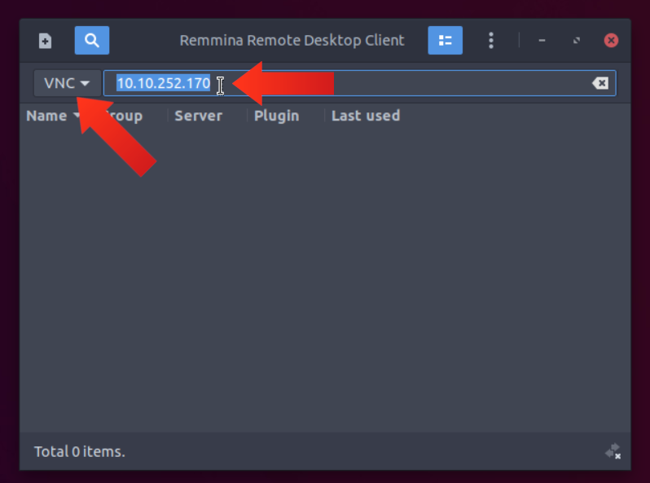

Top of Form

Bottom of Form

Top of Form

Bottom of Form

Top of Form

Bottom of Form

Task 11[Day 6] Email Analysis It's beginning to look a lot like phishing

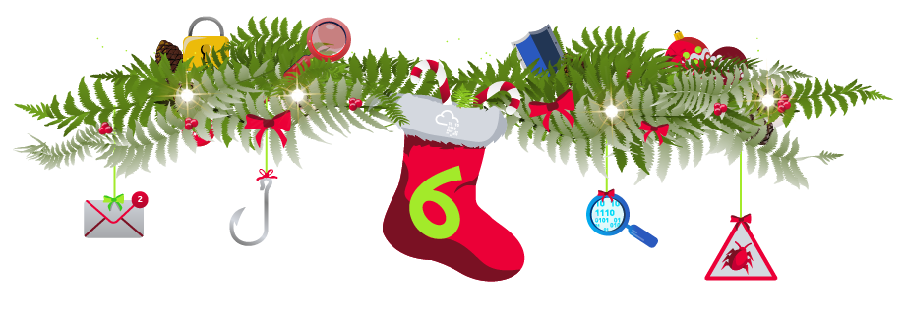

|  |  |
| --- | --- |
|  |  |
|  |  |
|  |  |
|  |  |
|  |  |
|  |  |
|  |  |
|  |  |
|  |  |
|  |  |
|  |  |
|  |  |
|  |  |
|  |  |

|  |  |
| --- | --- |
|  |  |
|  |  |
|  |  |
|  |  |
|  |  |
|  |  |
|  |  |
|  |  |



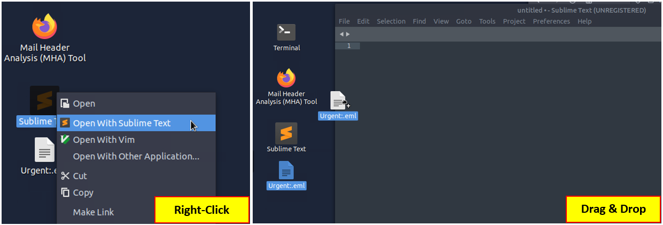

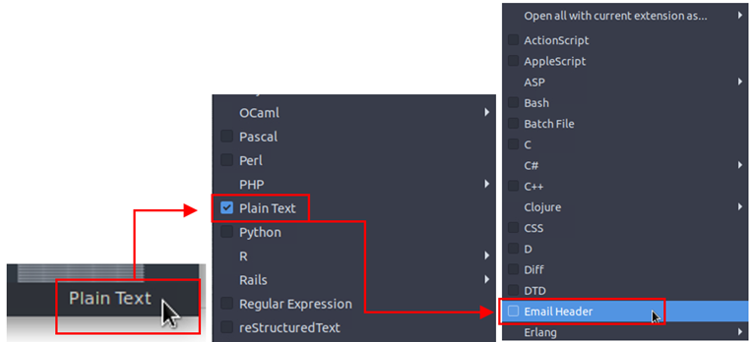

|  |  |
| --- | --- |
|  |  |
|  |  |
|  |  |
|  |  |
|  |  |
|  |  |
|  |  |



|  |  |
| --- | --- |
|  |  |
|  |  |
|  |  |
|  |  |
|  |  |
|  |  |
|  |  |
|  |  |

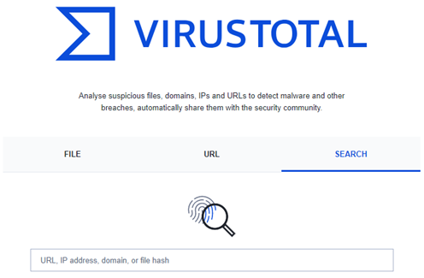



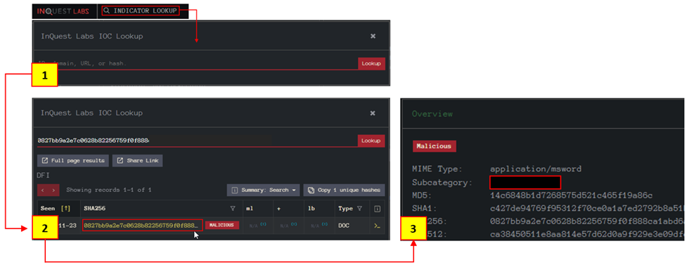

Top of Form

Bottom of Form

Top of Form

Bottom of Form

Top of Form

Bottom of Form

Top of Form

Bottom of Form

Top of Form

Bottom of Form

Top of Form

Bottom of Form

Top of Form

Bottom of Form

Top of Form

Bottom of Form

Top of Form

Bottom of Form

Top of Form

Bottom of Form

Top of Form

Bottom of Form

Task 12[Day 7] CyberChef Maldocs roasting on an open fire

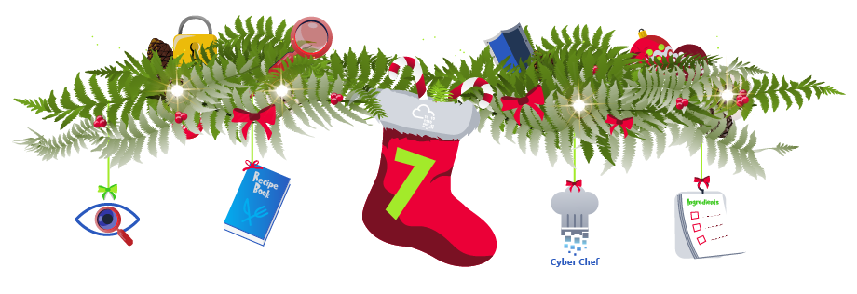



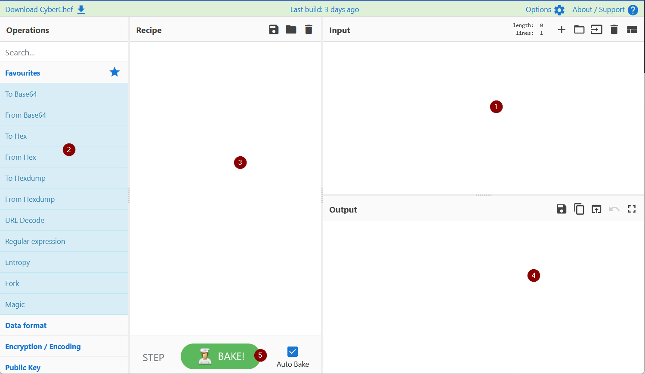





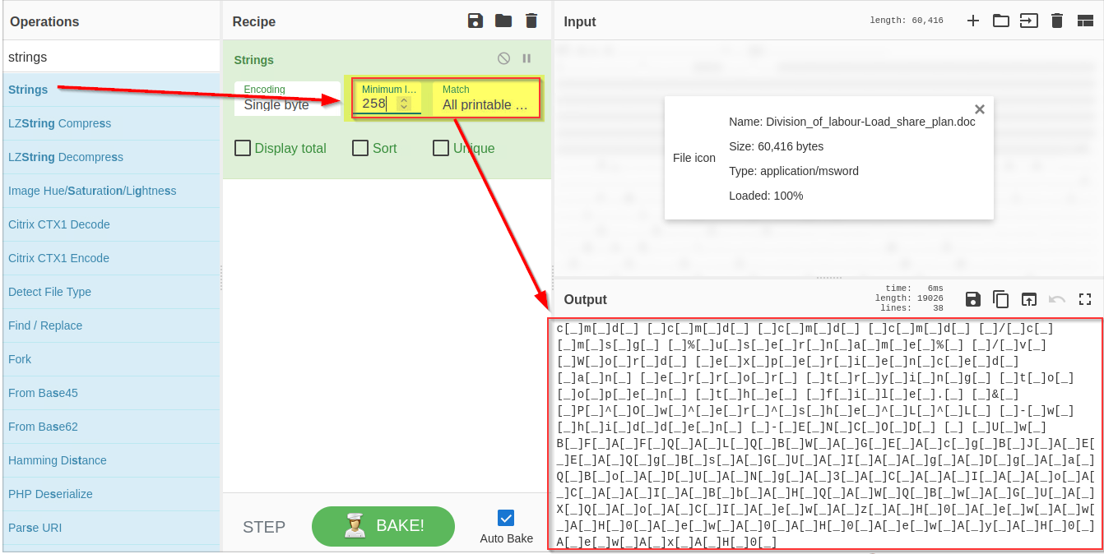

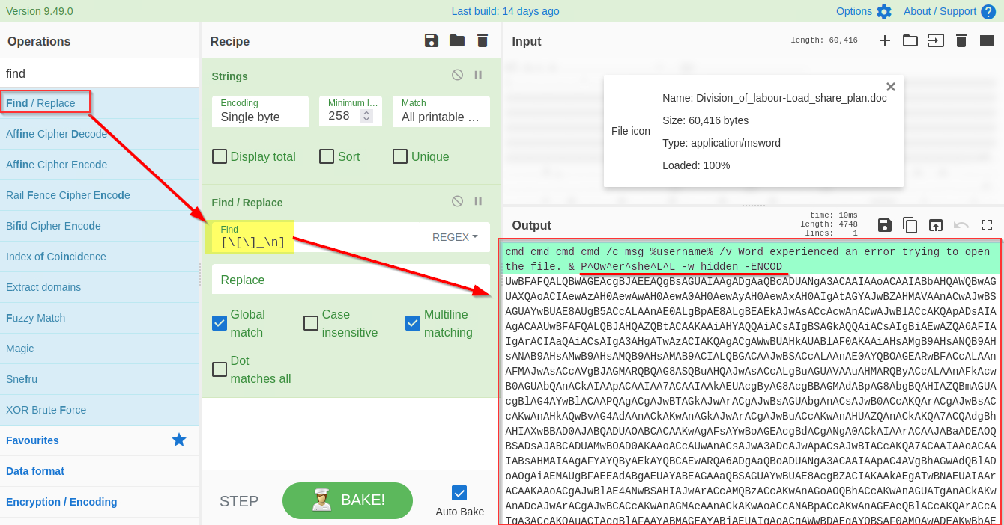

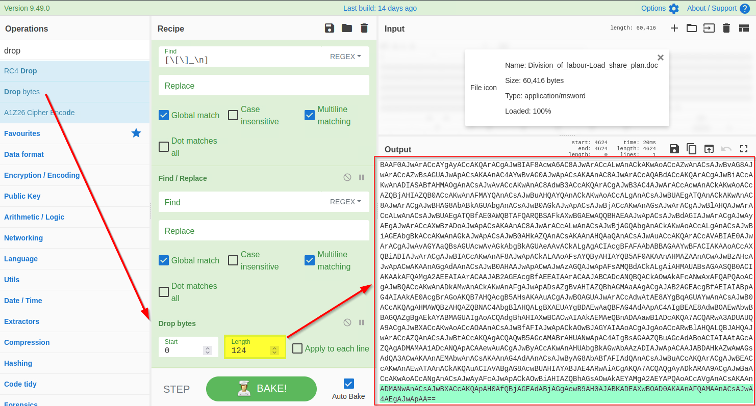

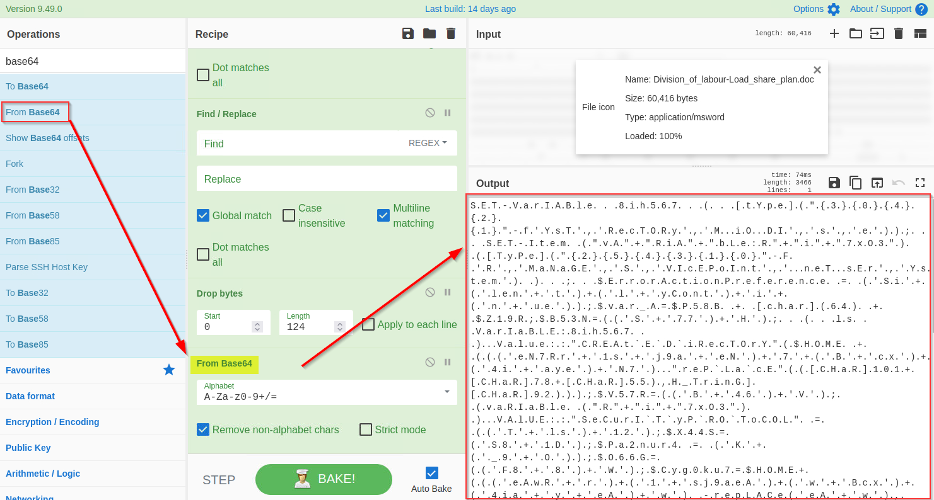

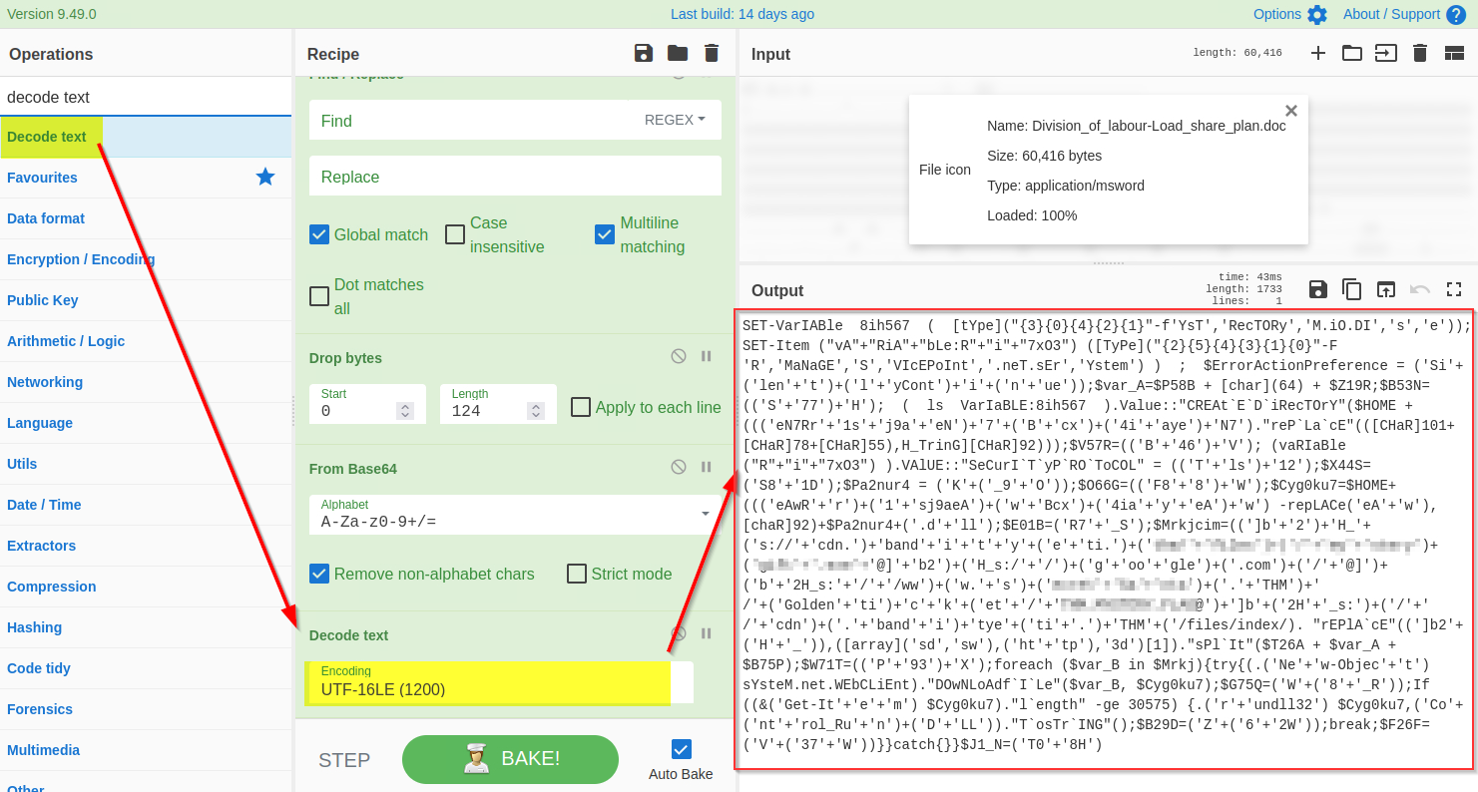

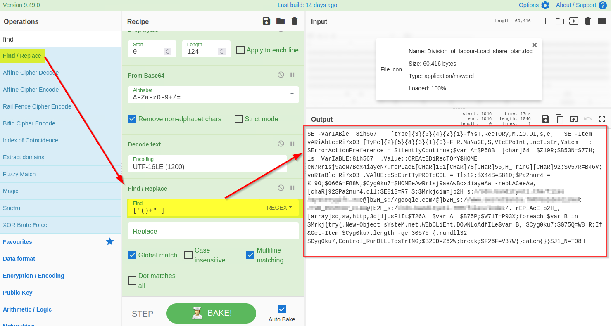

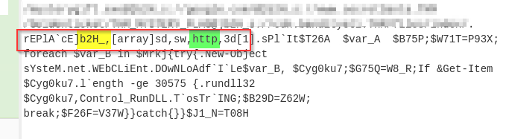

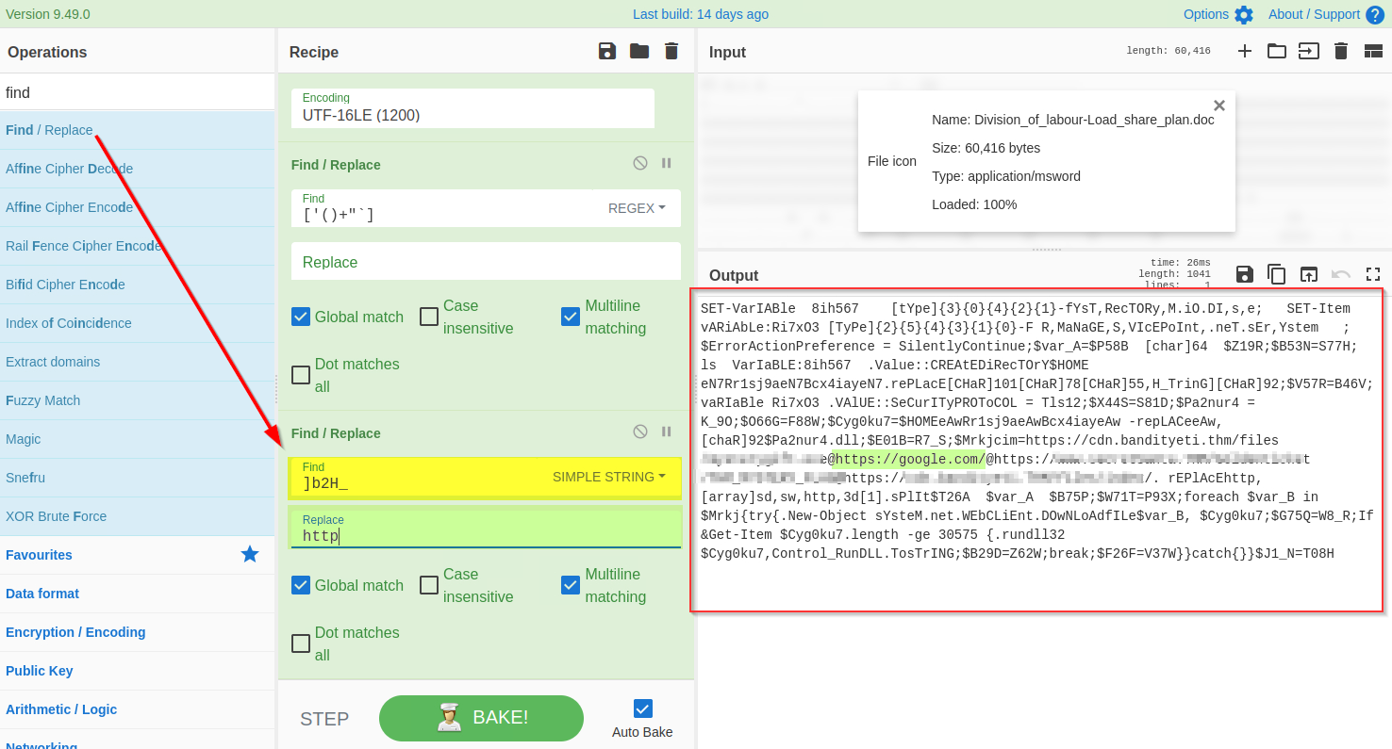

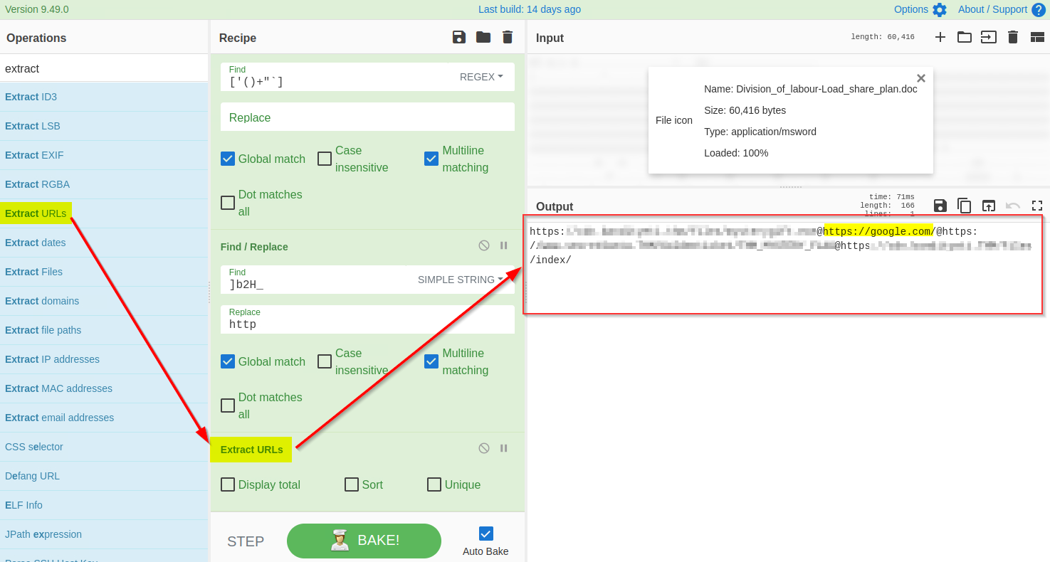

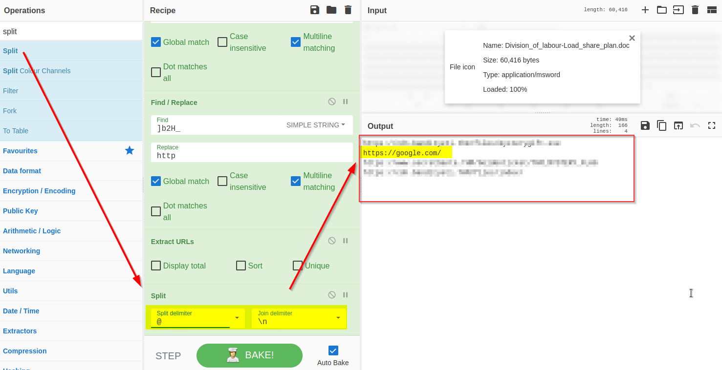

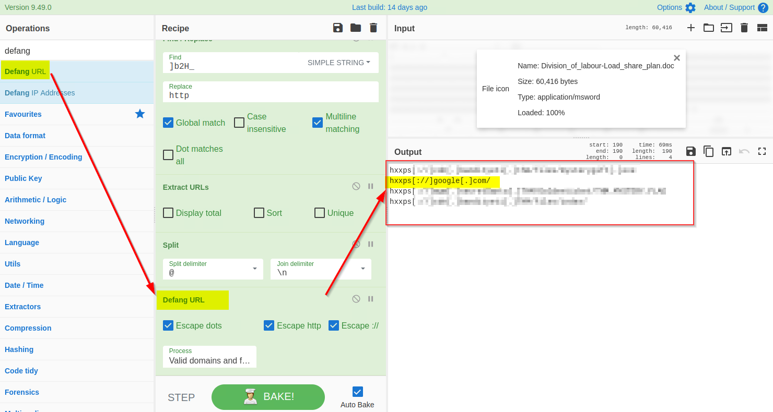

Top of Form

Bottom of Form

Top of Form

Bottom of Form

Top of Form

Bottom of Form

Top of Form

Bottom of Form

Top of Form

Bottom of Form

Top of Form

Bottom of Form

Task 13[Day 8] Smart Contracts Last Christmas I gave you my ETH

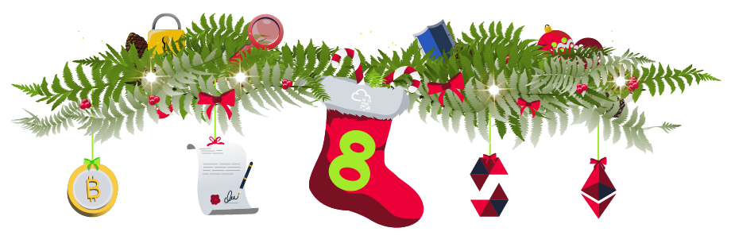

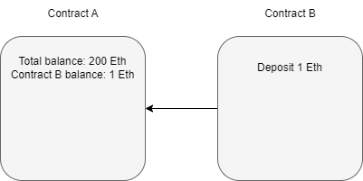

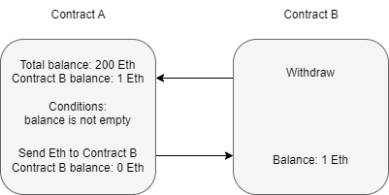

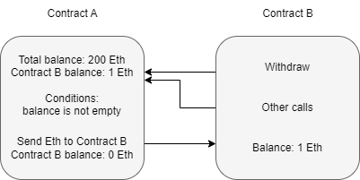

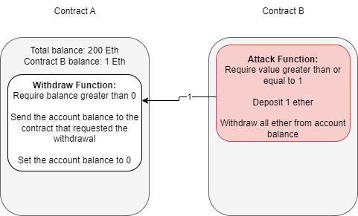

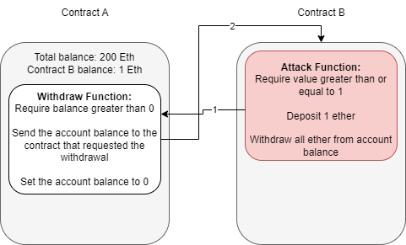

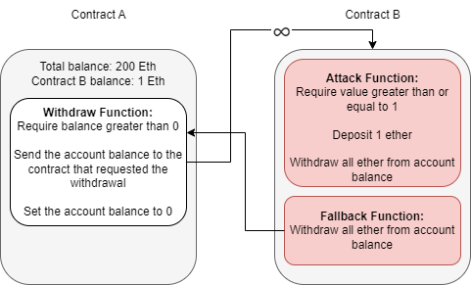

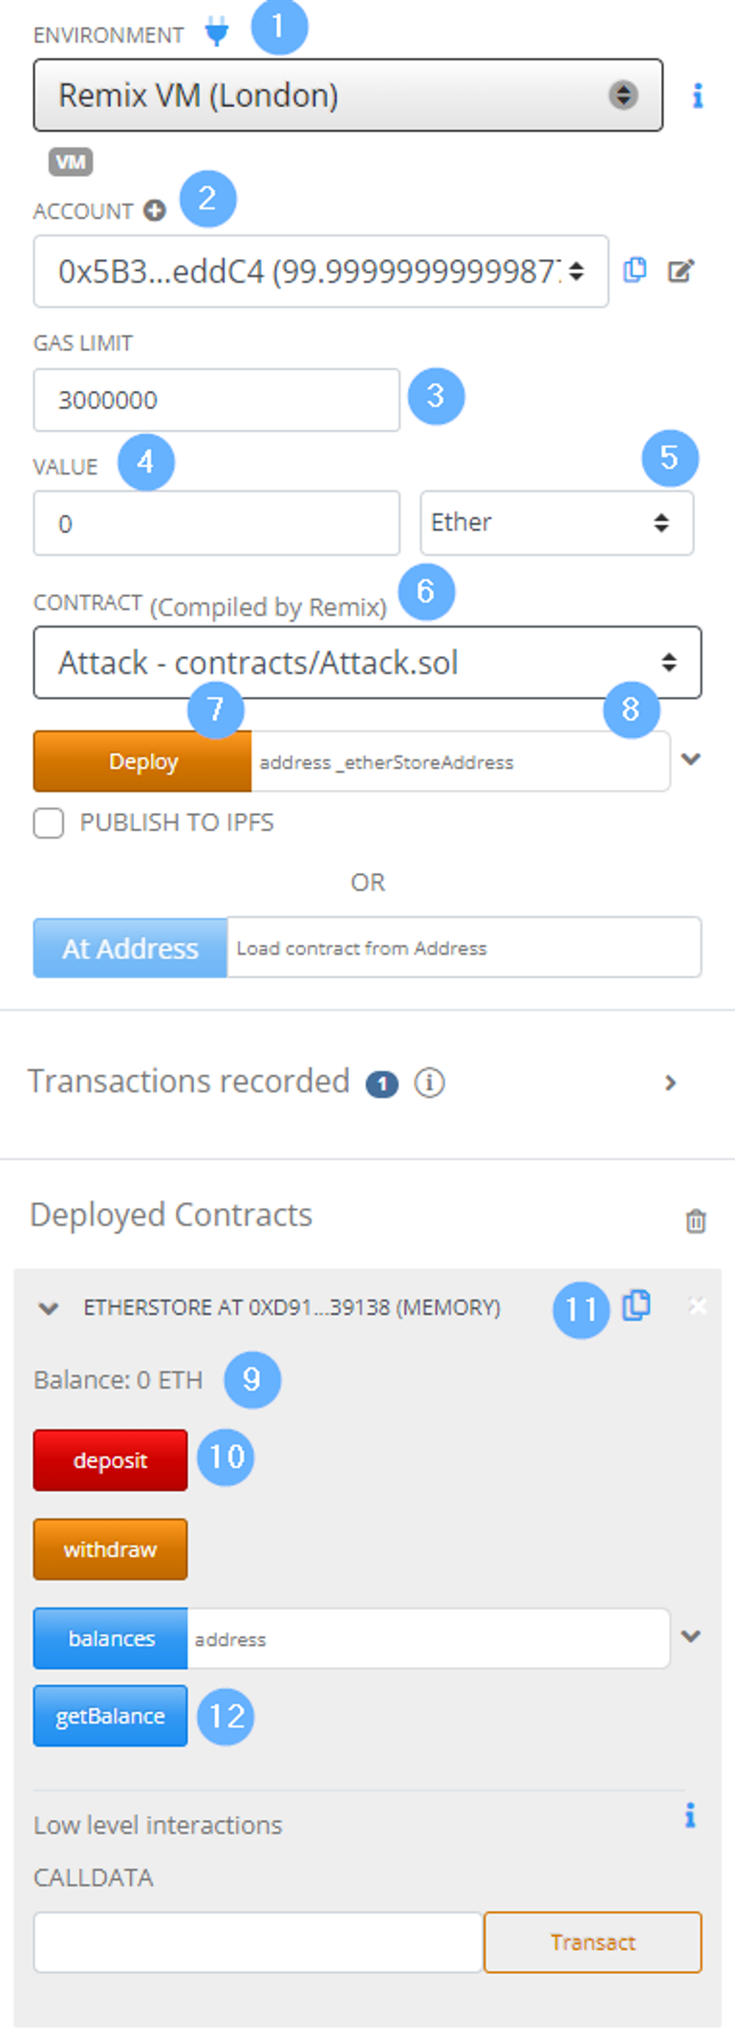



Top of Form

Bottom of Form

Top of Form

Bottom of Form

Top of Form

Bottom of Form

Task 14[Day 9] Pivoting Dock the halls





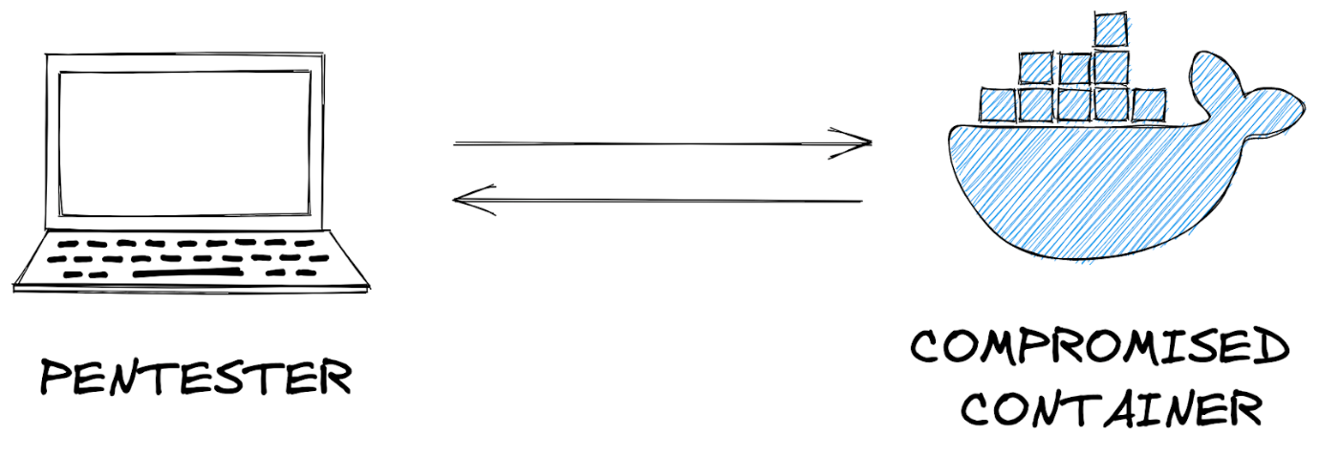

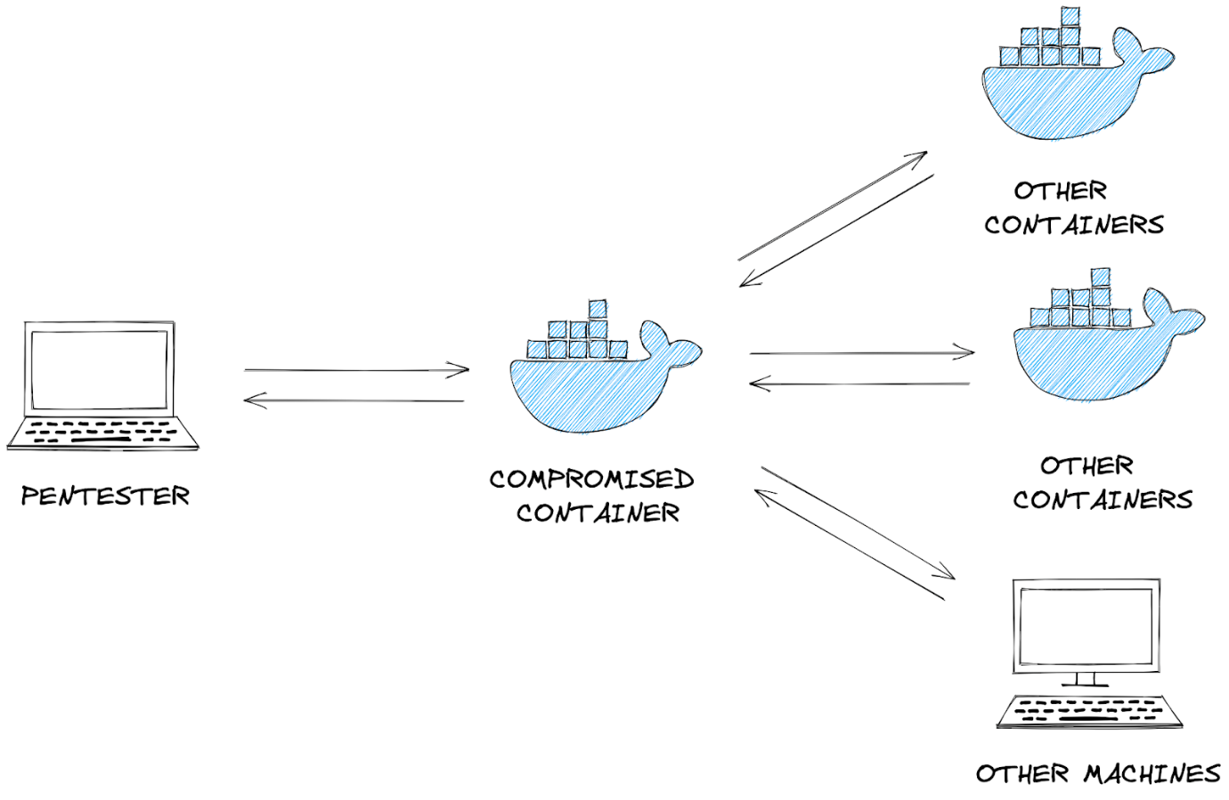

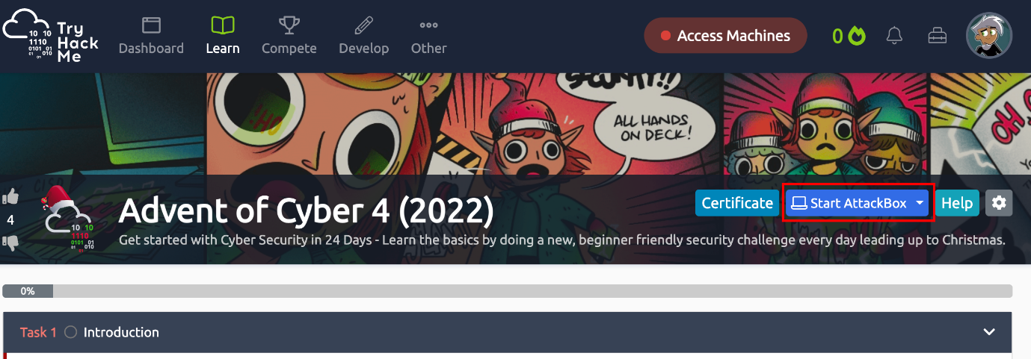

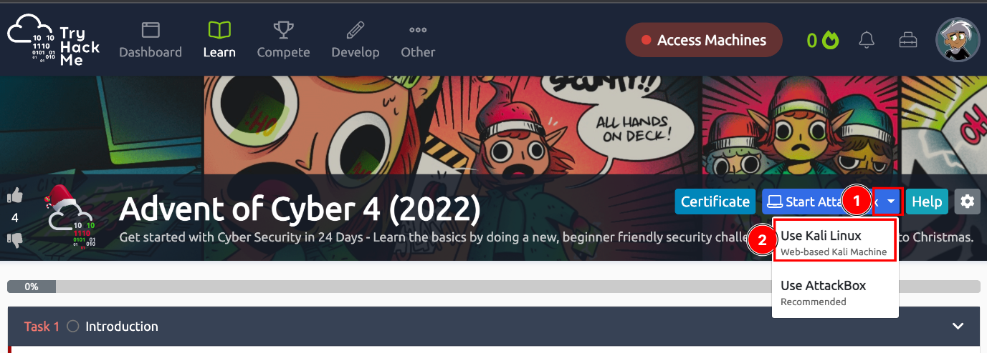

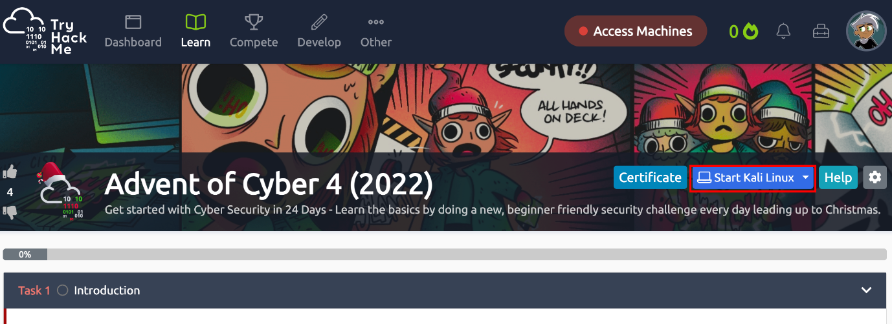

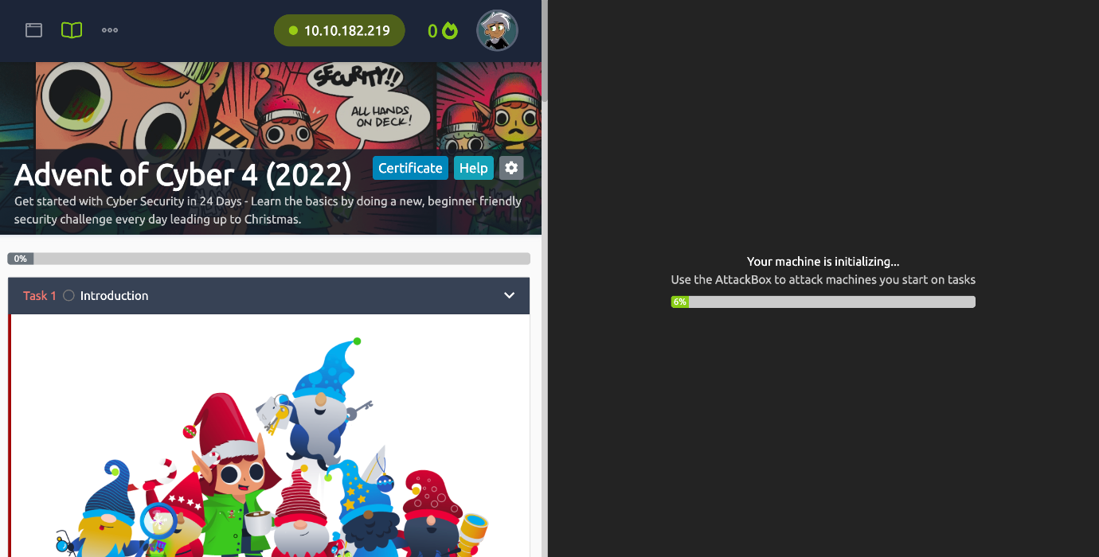

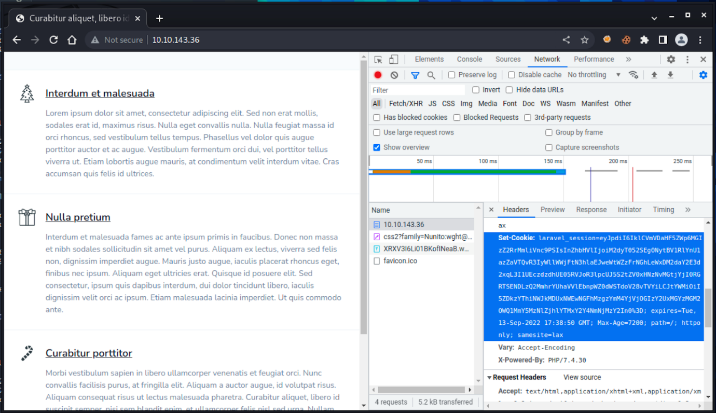

Top of Form

Bottom of Form

Top of Form

Bottom of Form

Top of Form

Bottom of Form

Top of Form

Bottom of Form

Top of Form

Bottom of Form

Top of Form

Bottom of Form

Top of Form

Bottom of Form

Top of Form

Bottom of Form

Top of Form

Bottom of Form

Top of Form

Bottom of Form

Top of Form

Bottom of Form

Task 15[Day 10] Hack a game You're a mean one, Mr. Yeti



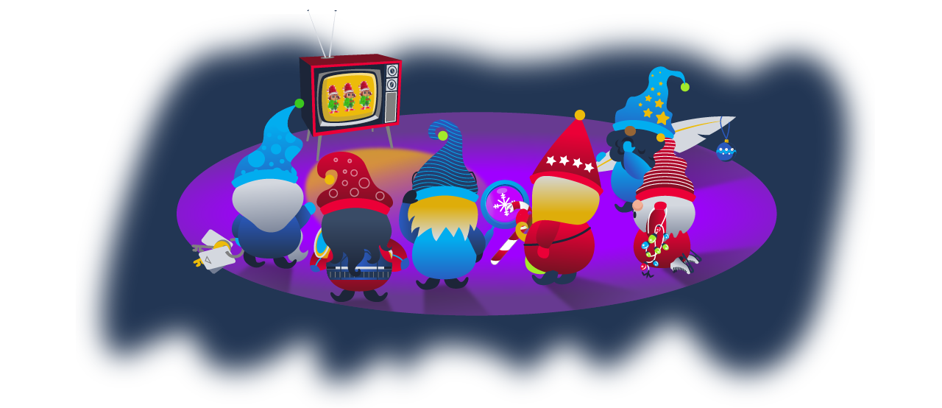

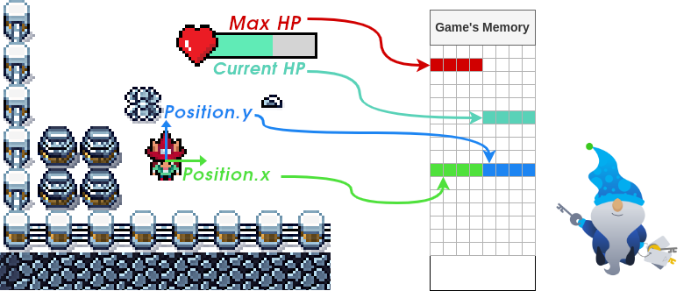



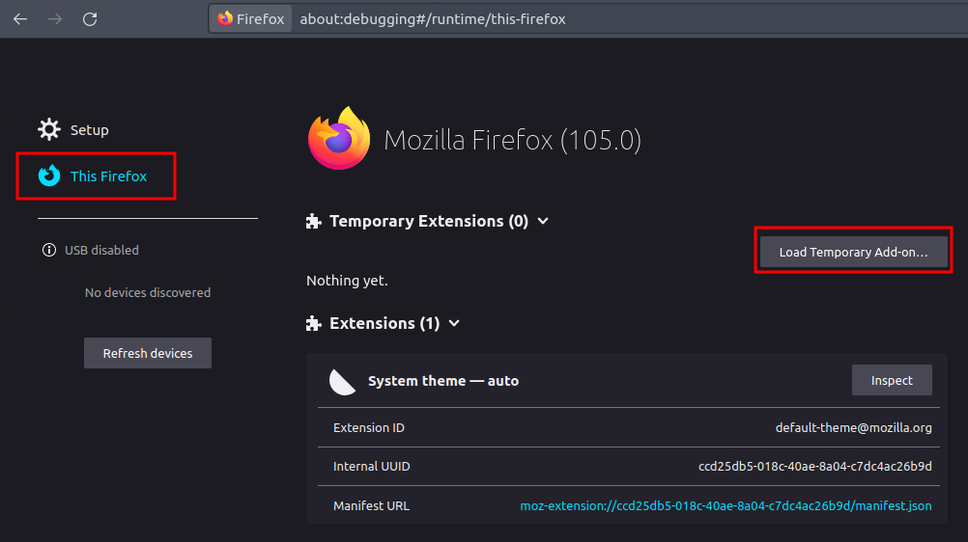

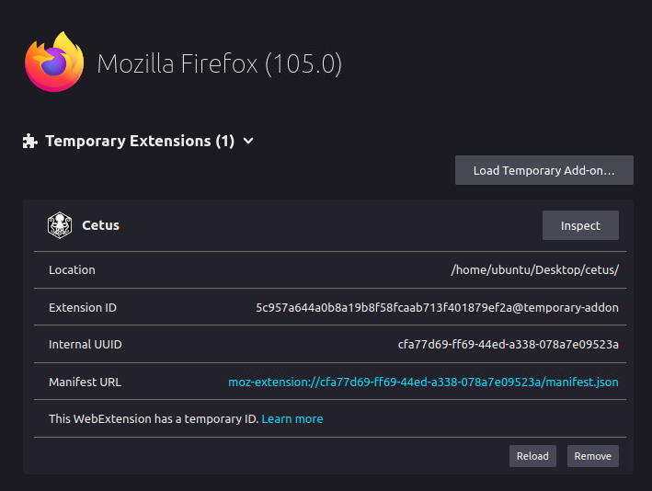

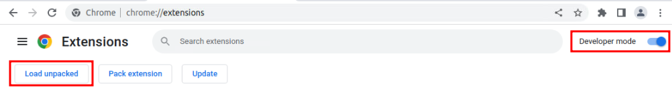

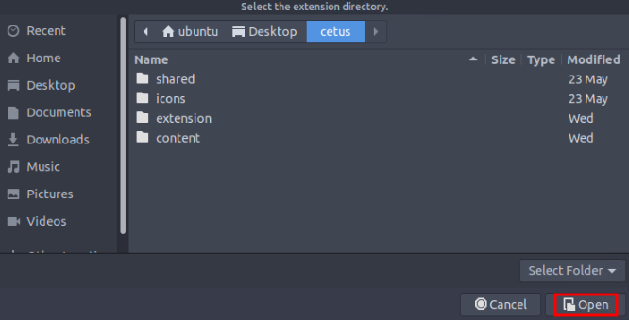

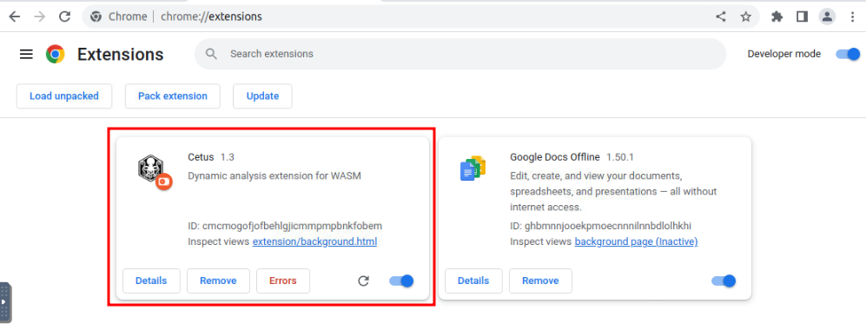

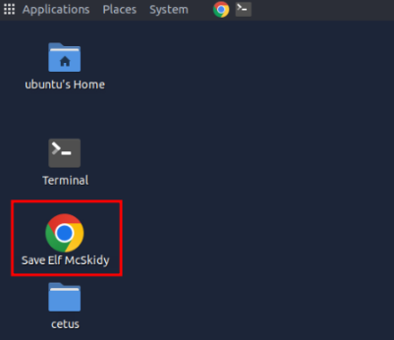

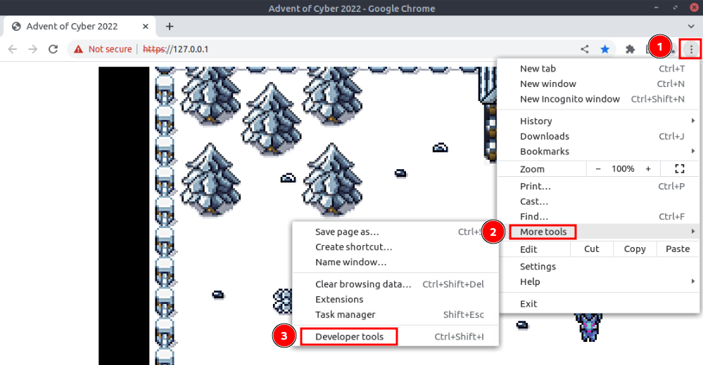

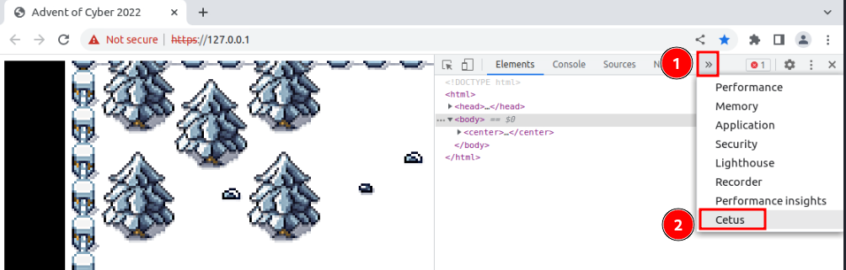

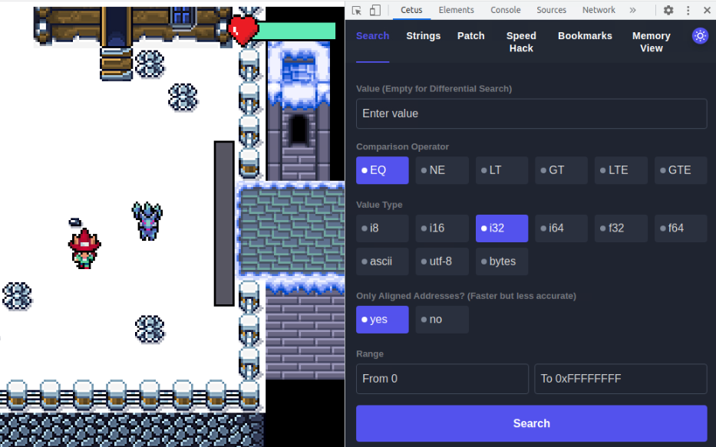

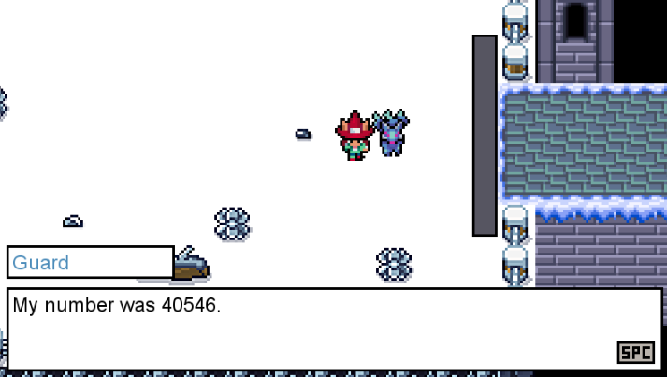

|  |  |
| --- | --- |
|  |  |
|  |  |
|  |  |
|  |  |
|  |  |
|  |  |
|  |  |

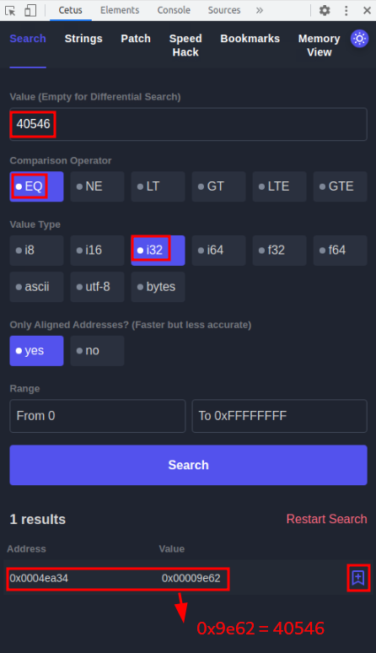

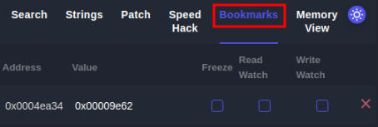

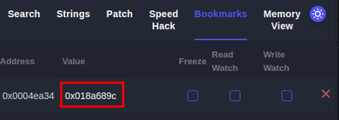

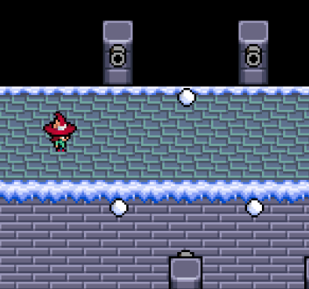

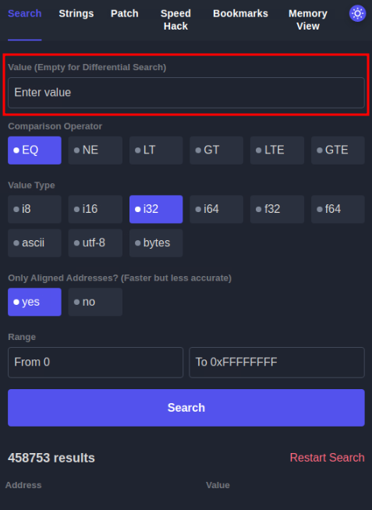

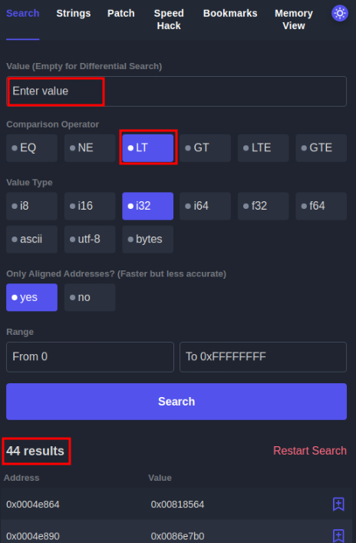

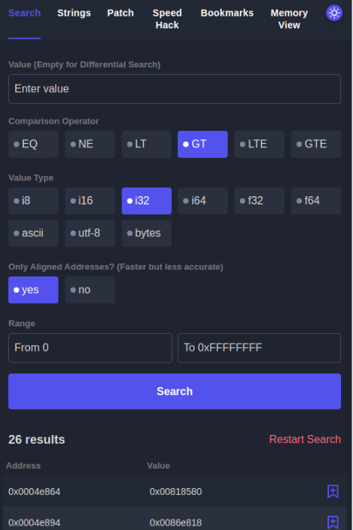

Top of Form

Bottom of Form

Top of Form

Bottom of Form

Top of Form

Bottom of Form

Task 16[Day 11] Memory Forensics Not all gifts are nice

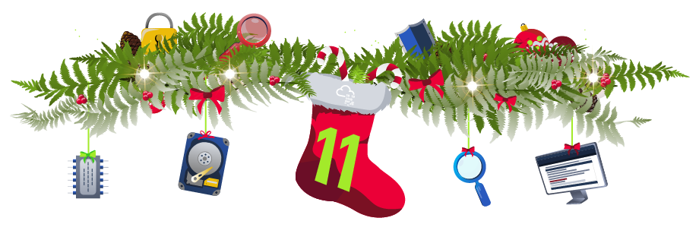





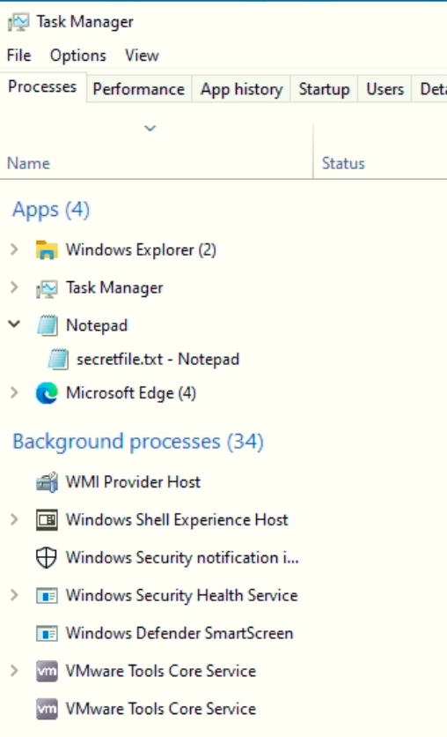

|  |  |  |
| --- | --- | --- |
|  |  |  |
|  |  |  |
|  |  |  |

|  |  |  |
| --- | --- | --- |
|  |  |  |
|  |  |  |
|  |  |  |
|  |  |  |
|  |  |  |

|  |  |  |
| --- | --- | --- |
|  |  |  |
|  |  |  |
|  |  |  |
|  |  |  |
|  |  |  |



Top of Form

Bottom of Form

Top of Form

Bottom of Form

Top of Form

Bottom of Form

Top of Form

Bottom of Form

Top of Form

Bottom of Form

Task 17[Day 12] Malware Analysis Forensic McBlue to the REVscue!

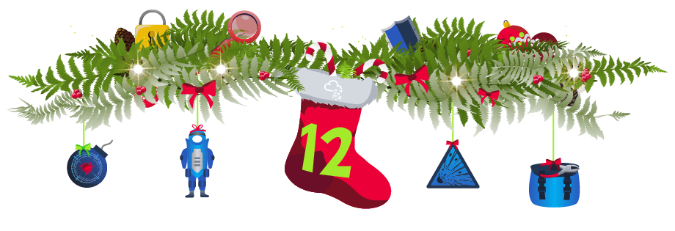

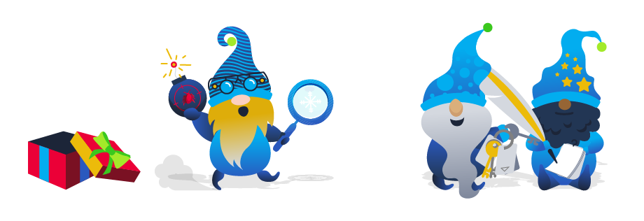



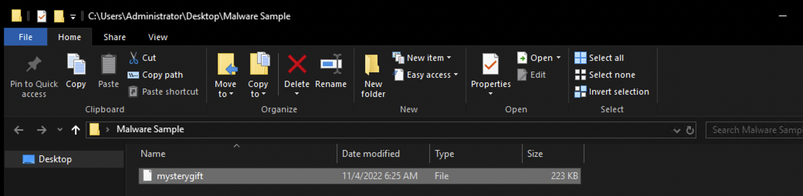

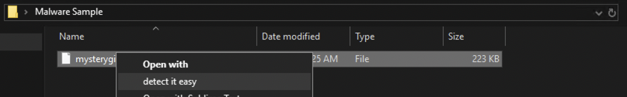

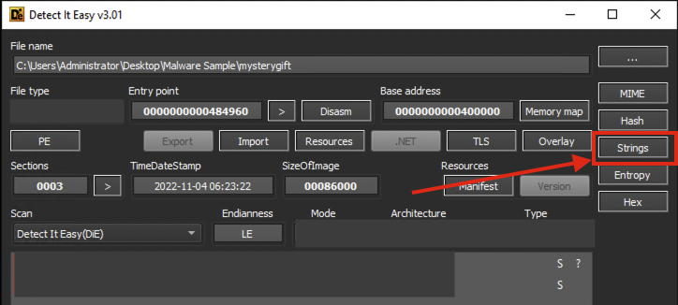



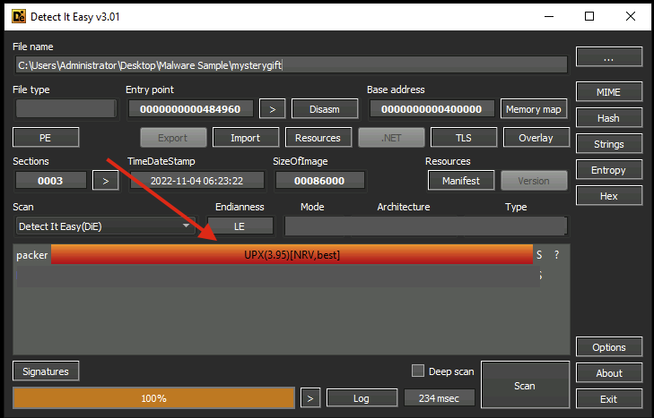

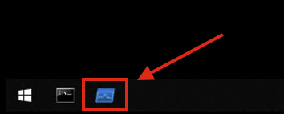

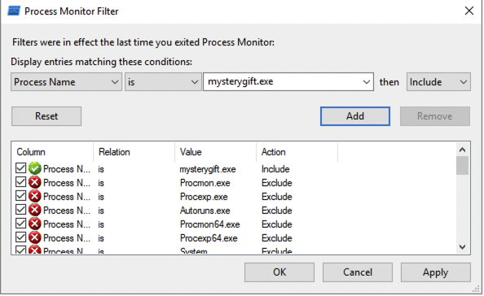

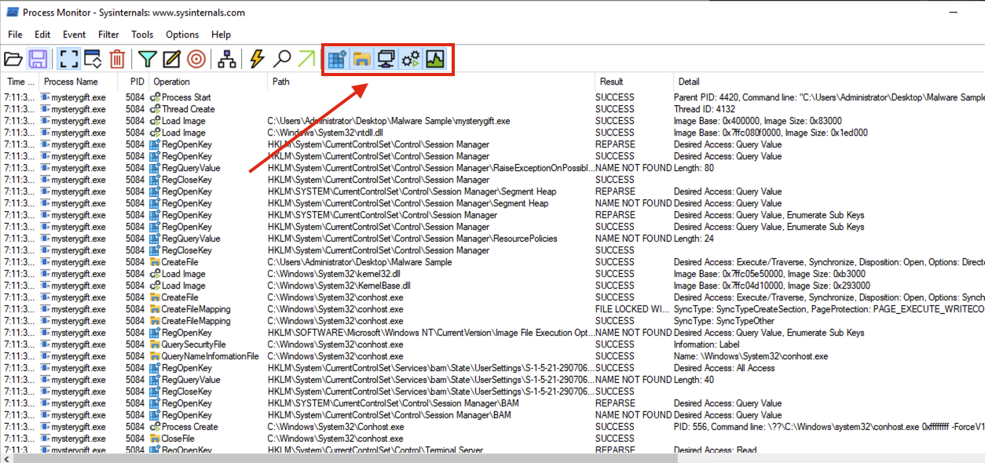

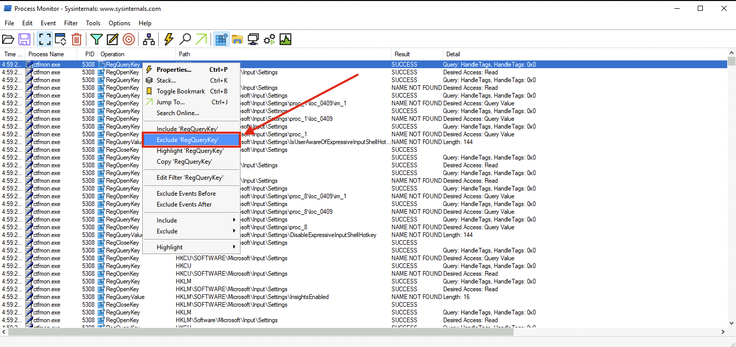

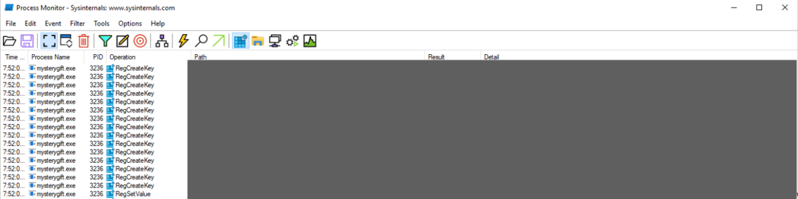

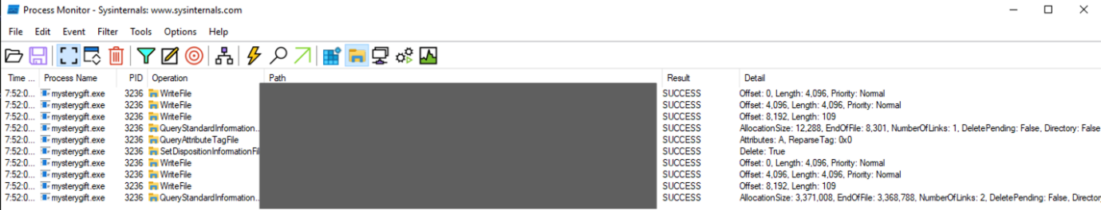

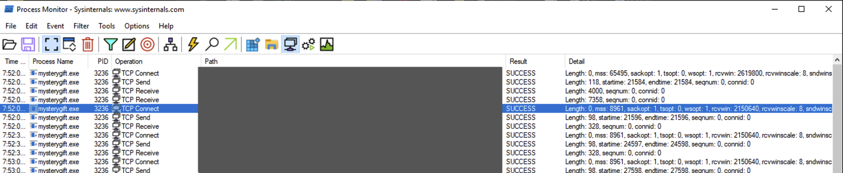

Top of Form

Bottom of Form

Top of Form

Bottom of Form

Top of Form

Bottom of Form

Top of Form

Bottom of Form

Top of Form

Bottom of Form

Top of Form

Bottom of Form

Top of Form

Bottom of Form

Top of Form

Bottom of Form

Top of Form

Bottom of Form

Top of Form

Bottom of Form

Task 18[Day 13] Packet Analysis Simply having a wonderful pcap time

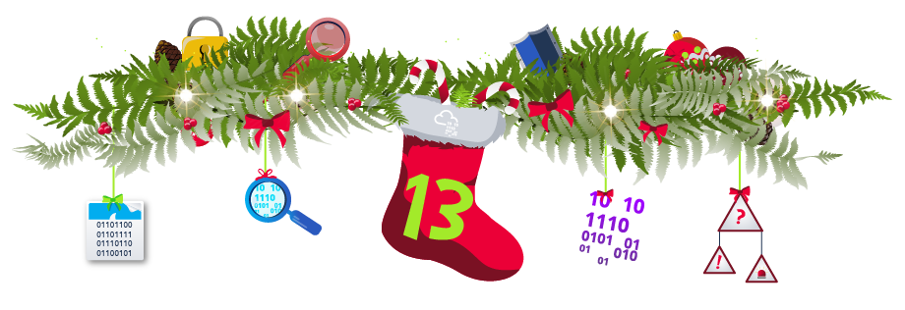

|  |  |
| --- | --- |
|  |  |
|  |  |
|  |  |
|  |  |

|  |  |
| --- | --- |
|  |  |
|  |  |
|  |  |
|  |  |
|  |  |
|  |  |
|  |  |

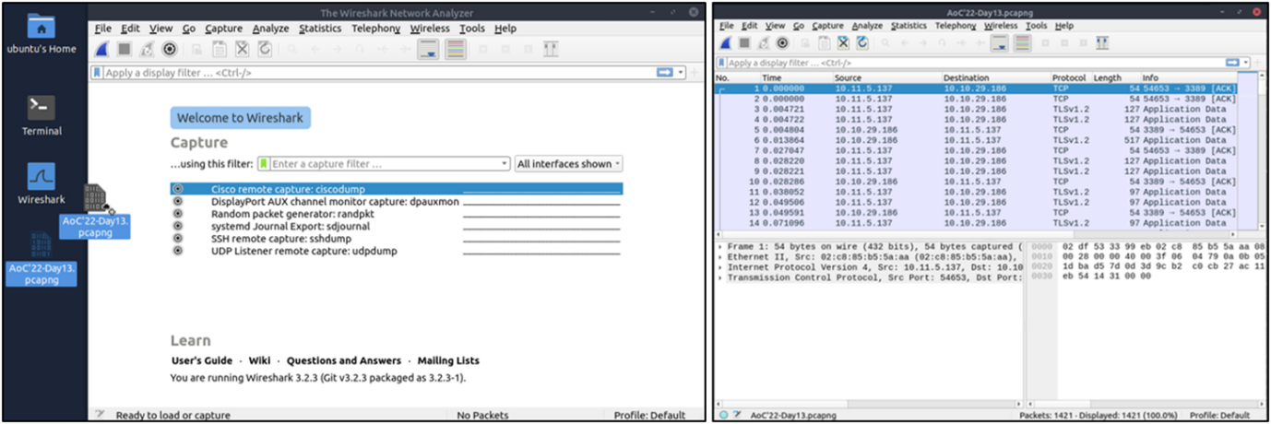

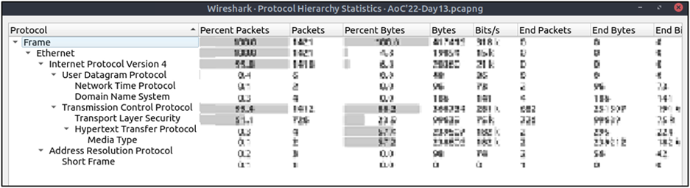

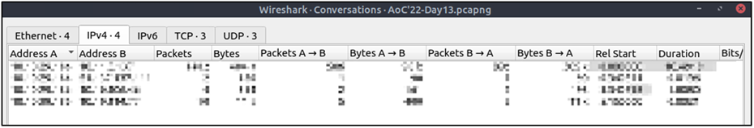



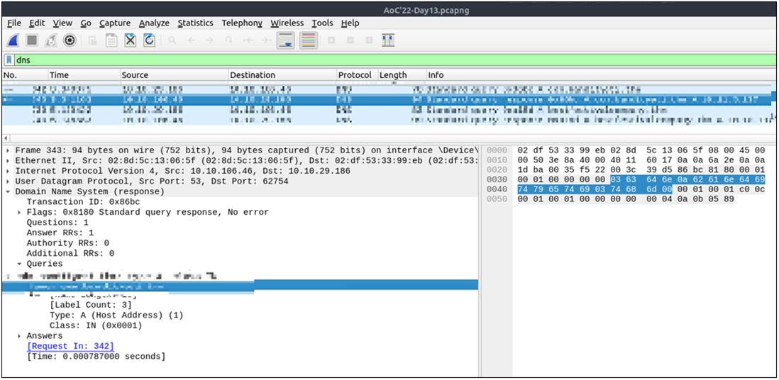

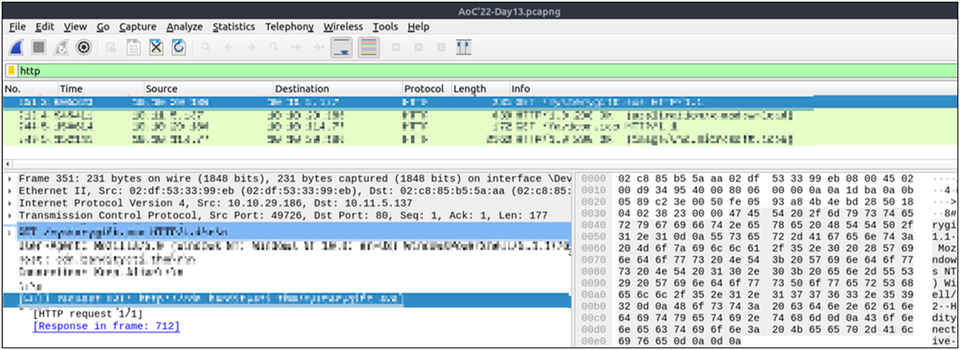

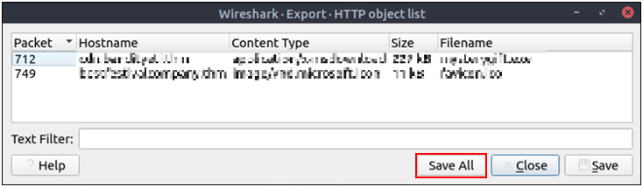



Top of Form

Bottom of Form

Top of Form

Bottom of Form

Top of Form

Bottom of Form

Top of Form

Bottom of Form

Top of Form

Bottom of Form

Top of Form

Bottom of Form

Top of Form

Bottom of Form

Top of Form

Bottom of Form

Top of Form

Bottom of Form

Top of Form

Bottom of Form

Top of Form

Bottom of Form

Task 19[Day 14] Web Applications I'm dreaming of secure web apps



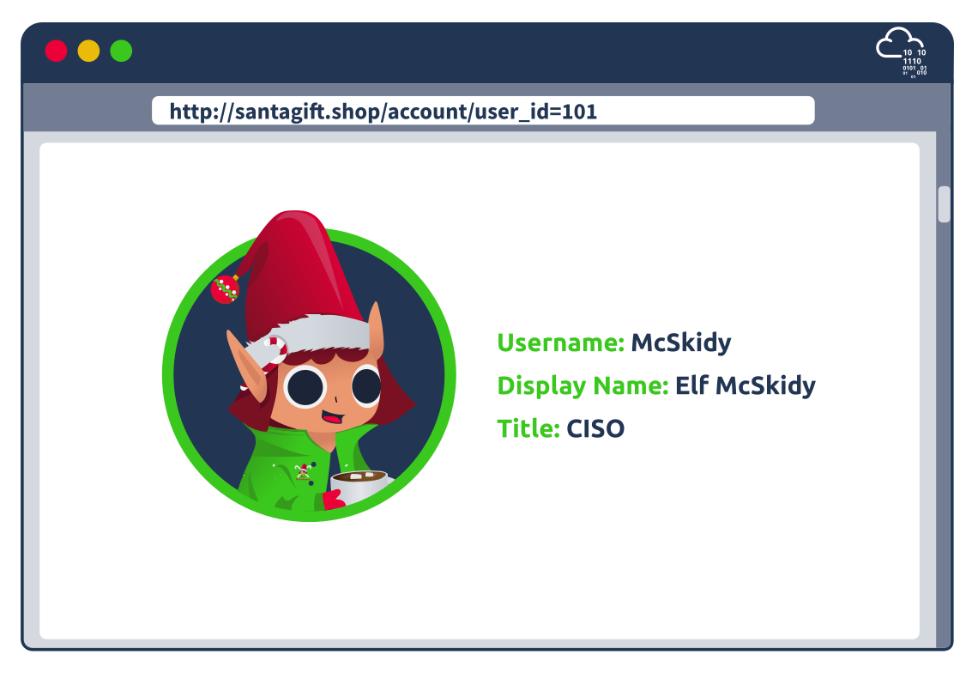

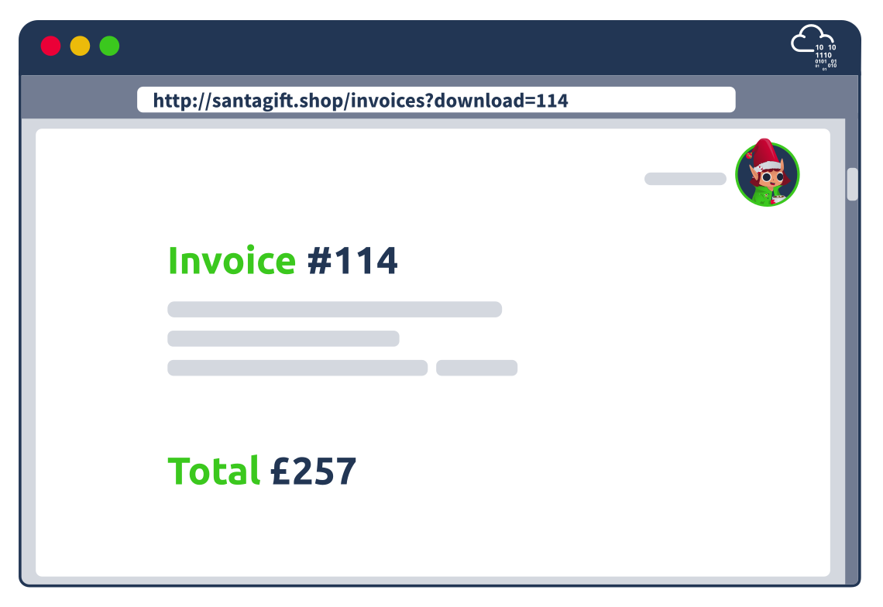

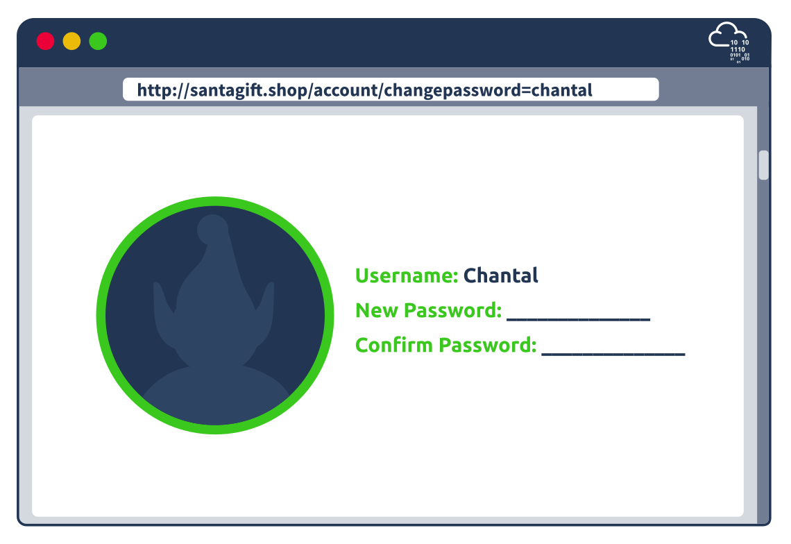

Top of Form

Bottom of Form

Top of Form

Bottom of Form

Top of Form

Bottom of Form

Task 20[Day 15] Secure Coding Santa is looking for a Sidekick

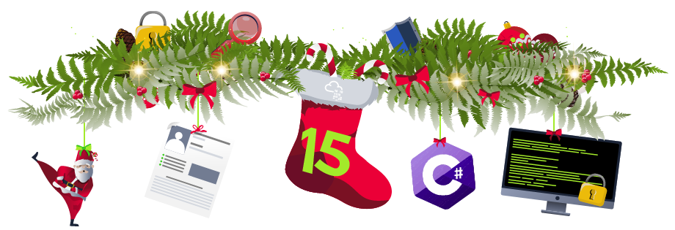



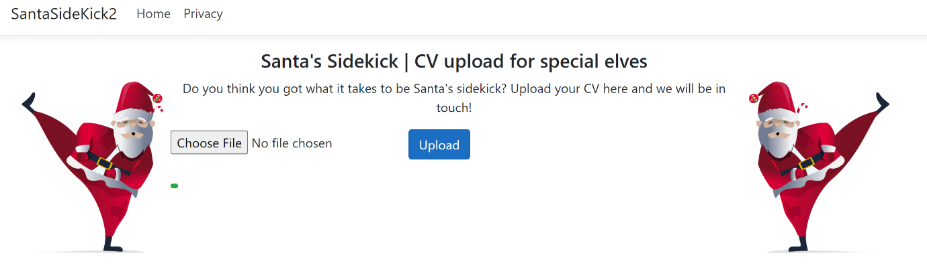

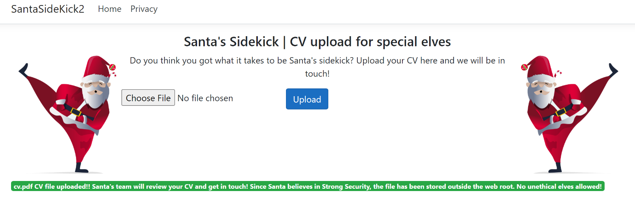

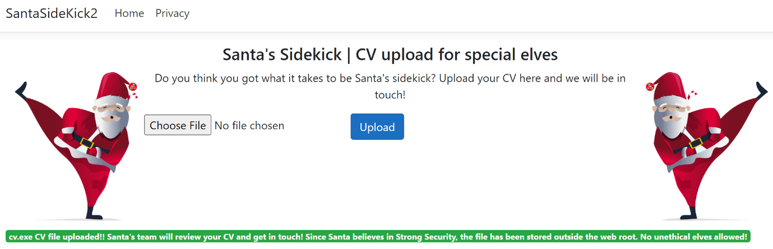

Top of Form

Bottom of Form

Top of Form

Bottom of Form

Top of Form

Bottom of Form

Top of Form

Bottom of Form

Top of Form

Bottom of Form

Top of Form

Bottom of Form

Top of Form

Bottom of Form

Task 21[Day 16] Secure Coding SQLi’s the king, the carolers sing



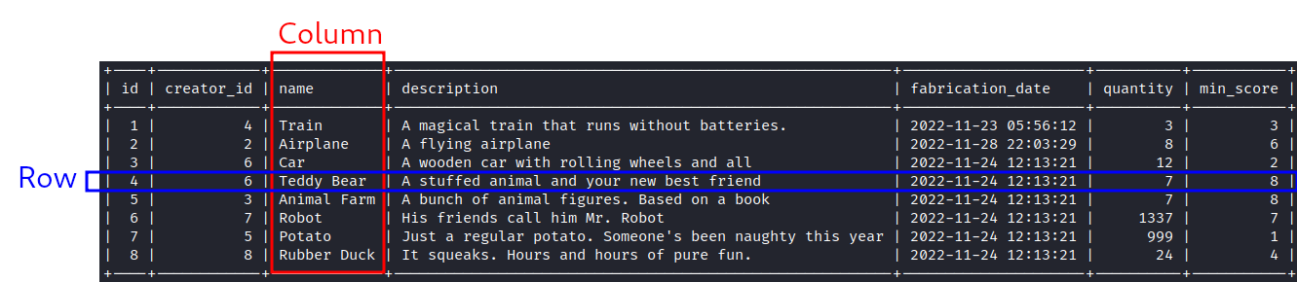

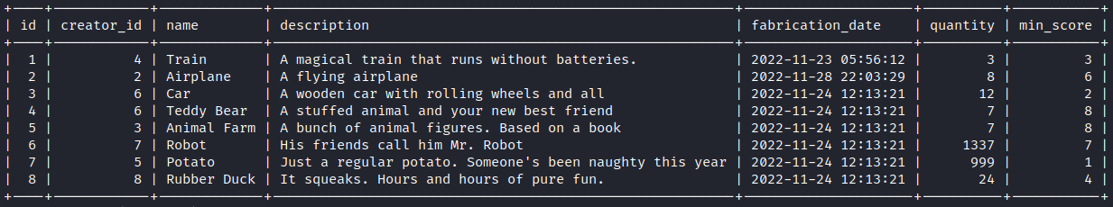

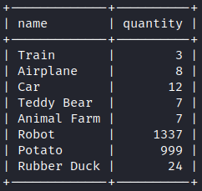

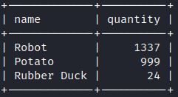

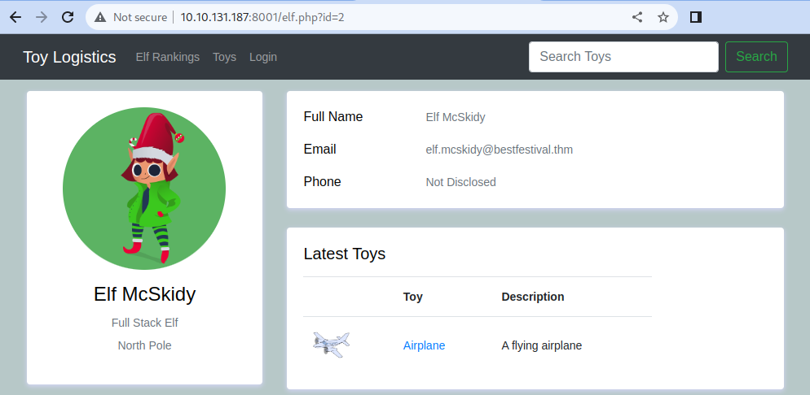



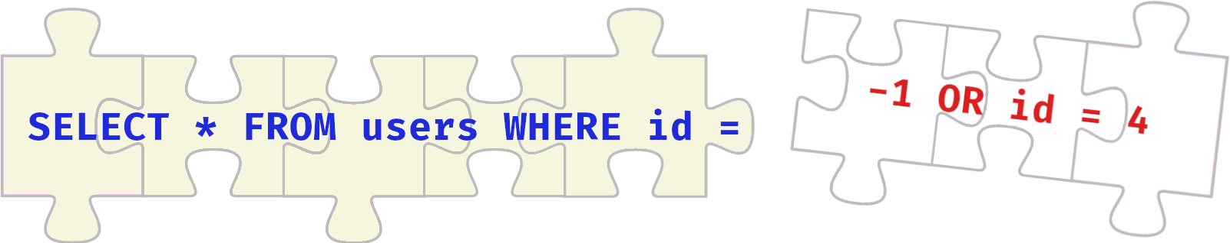



|  |  |
| --- | --- |
|  |  |
|  |  |

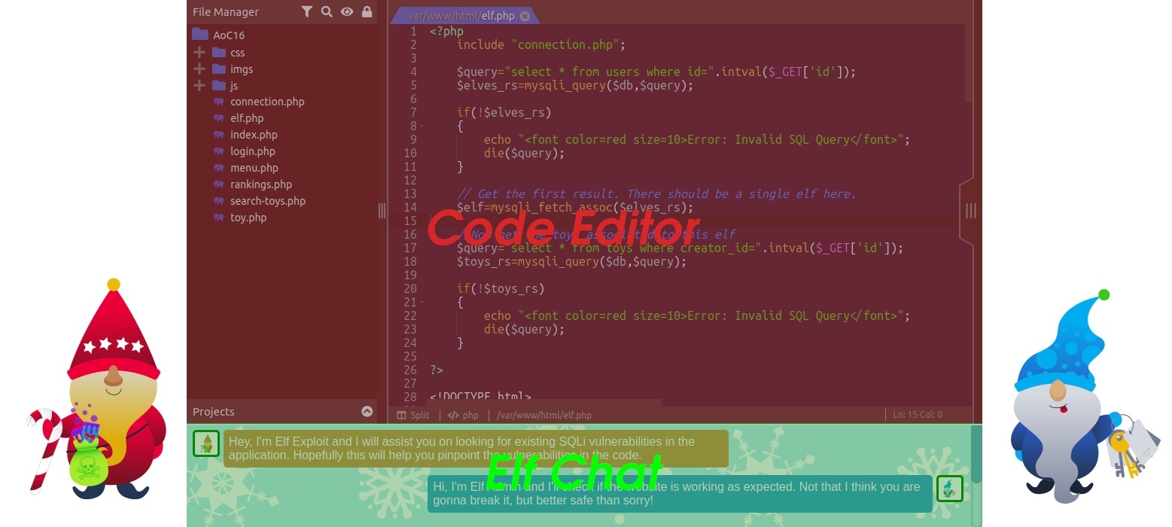



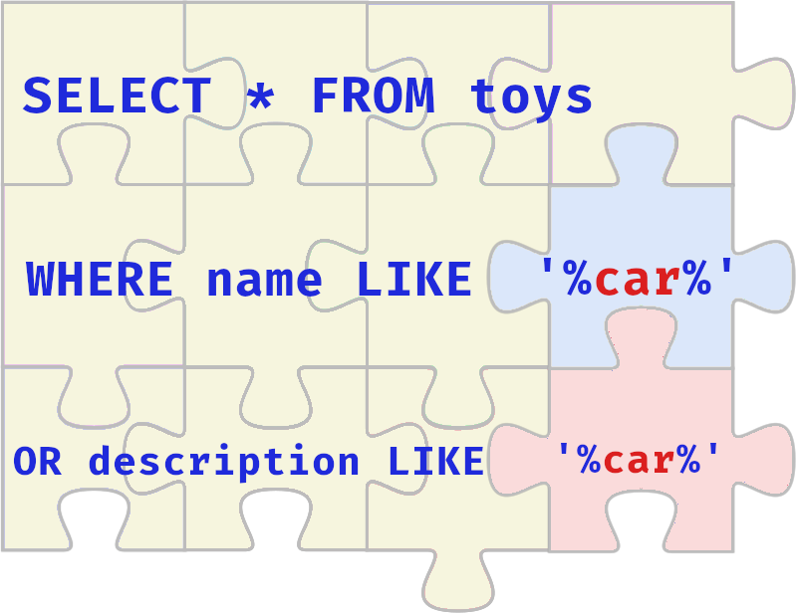

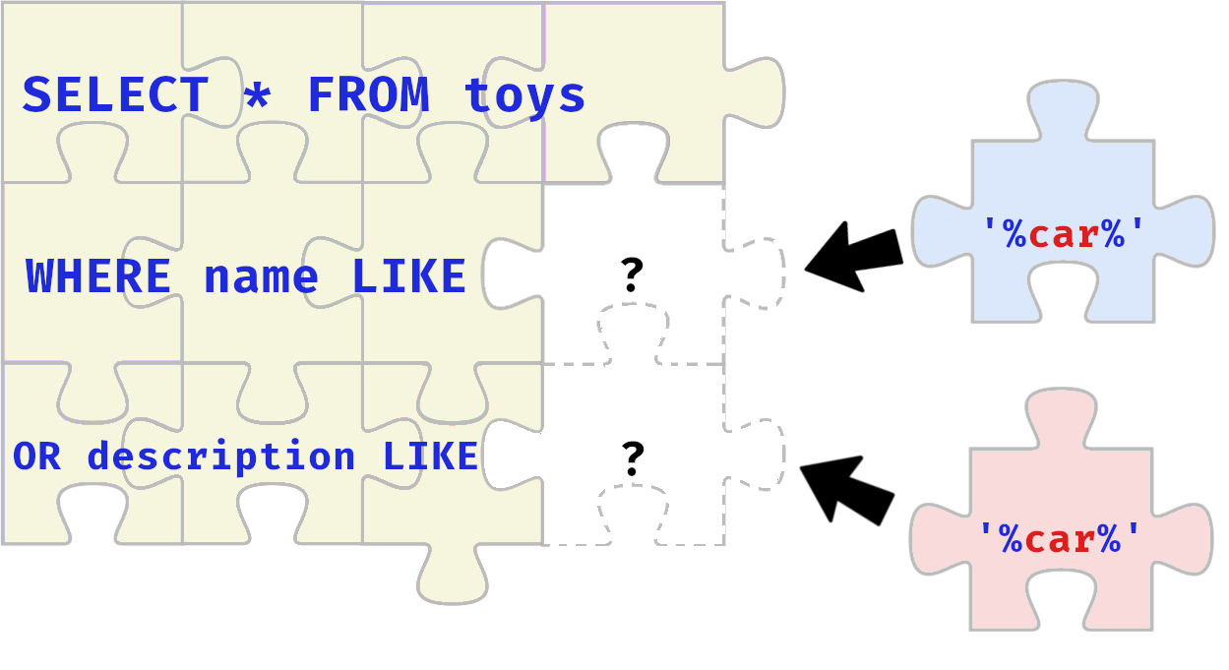

Top of Form

Bottom of Form

Top of Form

Bottom of Form

Top of Form

Bottom of Form

Top of Form

Bottom of Form

Top of Form

Bottom of Form

Task 22[Day 17] Secure Coding Filtering for Order Amidst Chaos

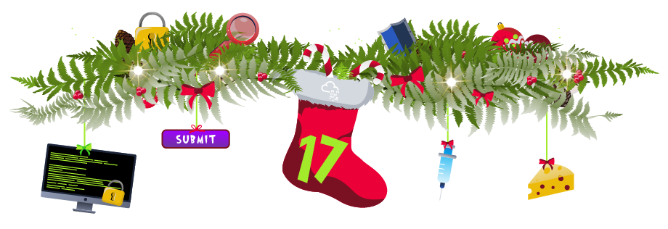

|  |  |
| --- | --- |
|  |  |
|  |  |
|  |  |
|  |  |
|  |  |
|  |  |
|  |  |
|  |  |
|  |  |
|  |  |

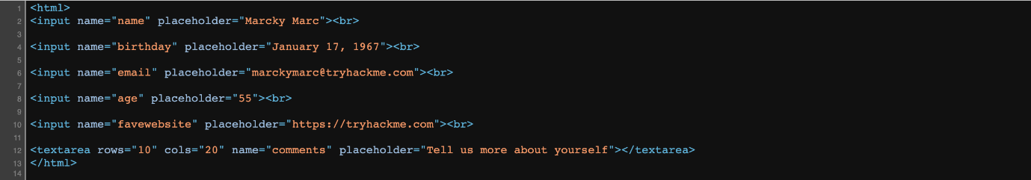

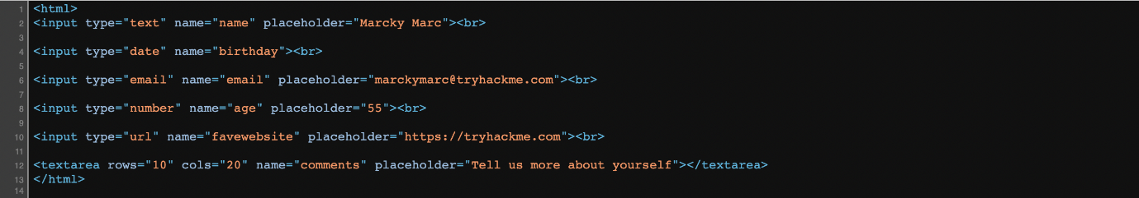

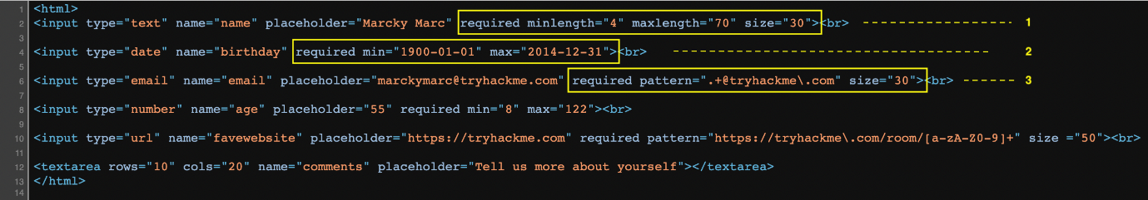

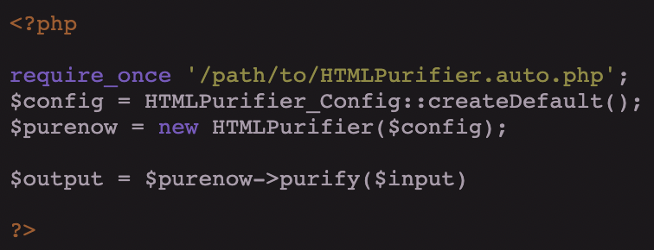

Top of Form

Bottom of Form

Top of Form

Bottom of Form

Top of Form

Bottom of Form

Top of Form

Bottom of Form

Top of Form

Bottom of Form

Top of Form

Bottom of Form

Top of Form

Bottom of Form

Top of Form

Bottom of Form

Top of Form

Bottom of Form

Top of Form

Bottom of Form

Task 23[Day 18] Sigma Lumberjack Lenny Learns New Rules

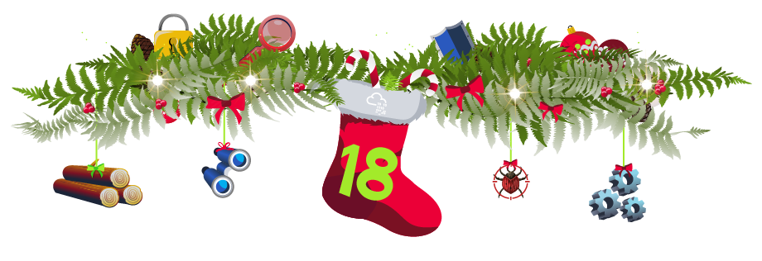

|  |  |  |
| --- | --- | --- |
|  |  |  |
|  |  |  |
|  |  |  |

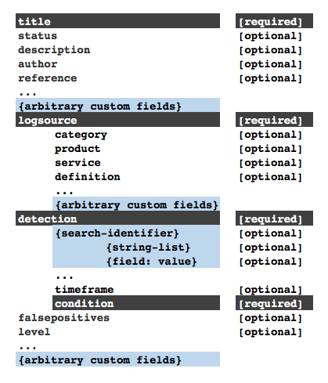





Top of Form

Bottom of Form

Top of Form

Bottom of Form

Top of Form

Bottom of Form

Top of Form

Bottom of Form

Top of Form

Bottom of Form

Top of Form

Bottom of Form

Top of Form

Bottom of Form

Task 24[Day 19] Hardware Hacking Wiggles go brrr

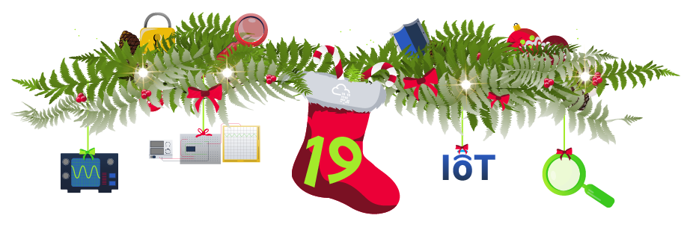

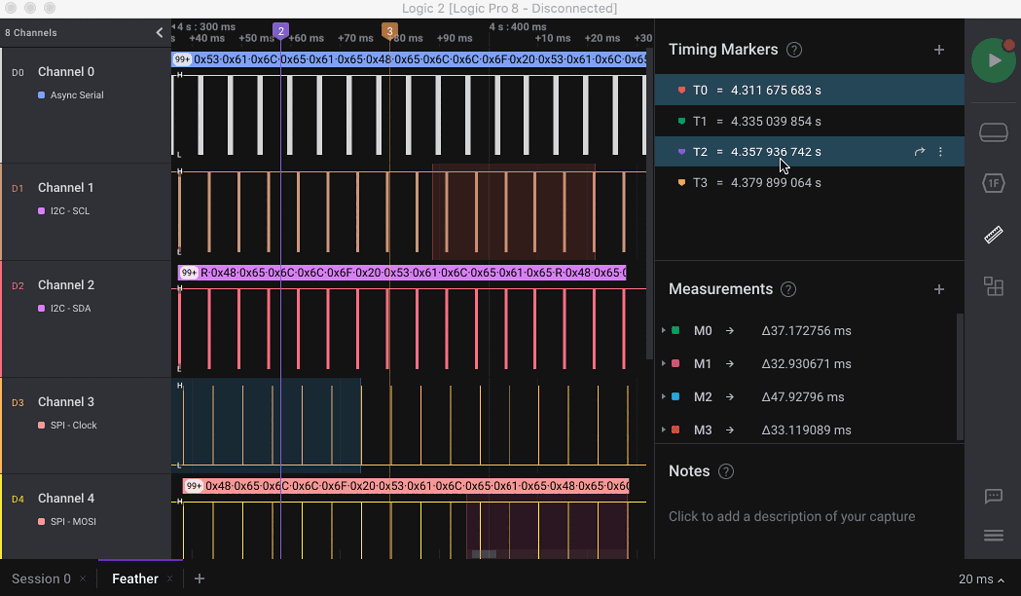



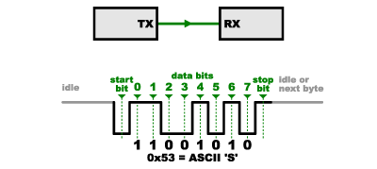

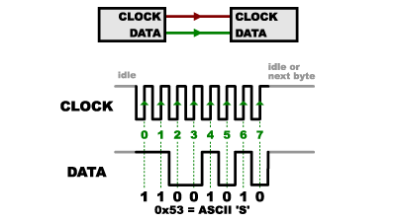

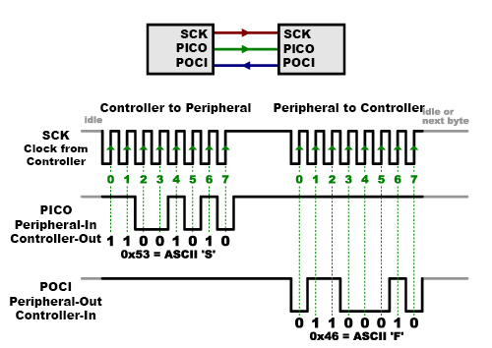

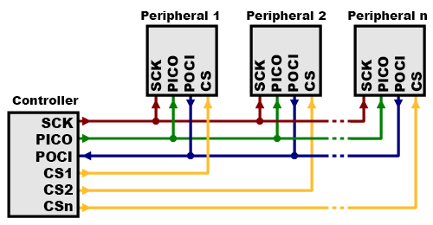

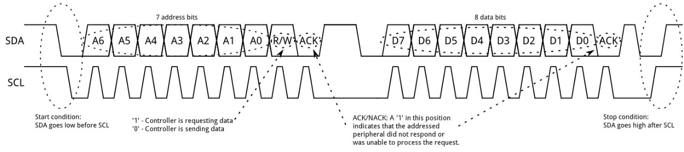

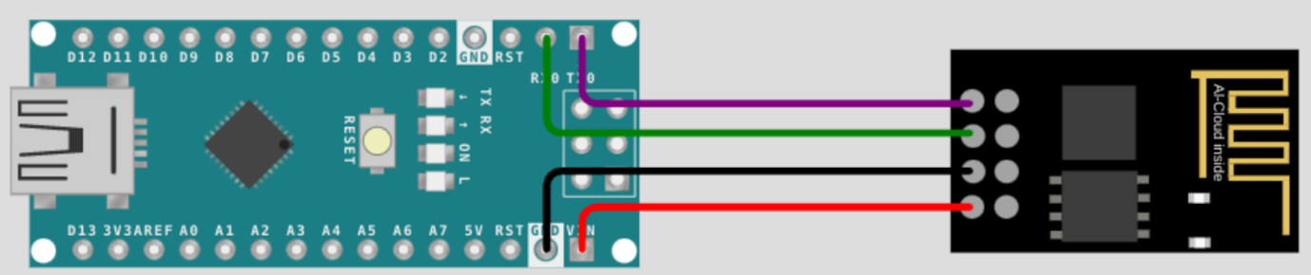





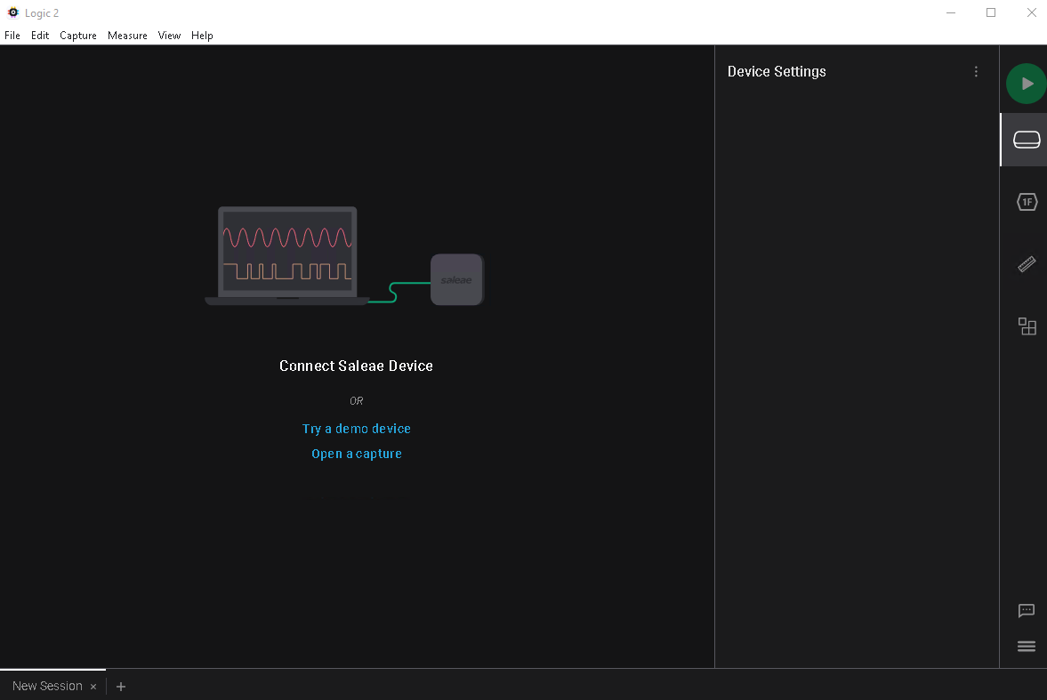

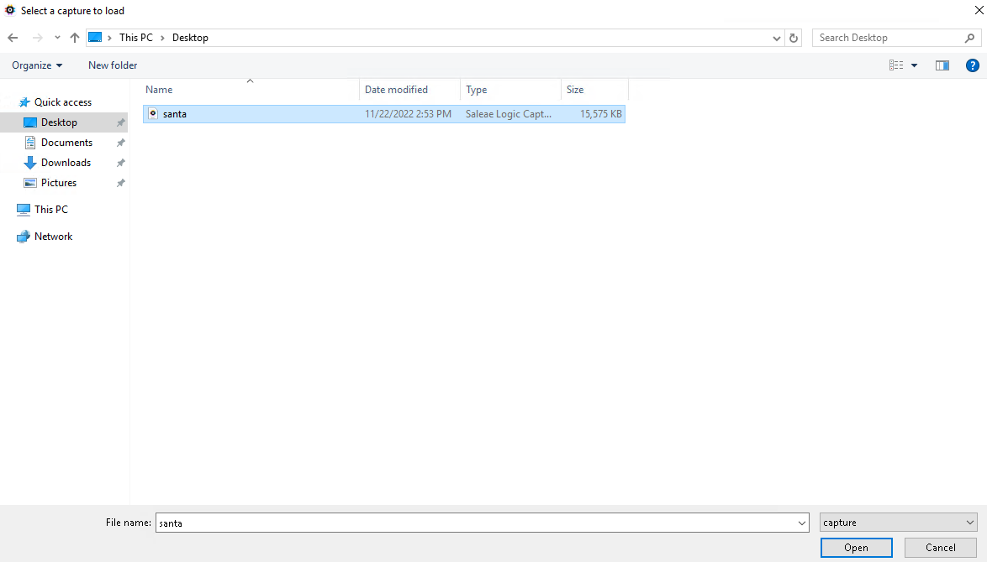

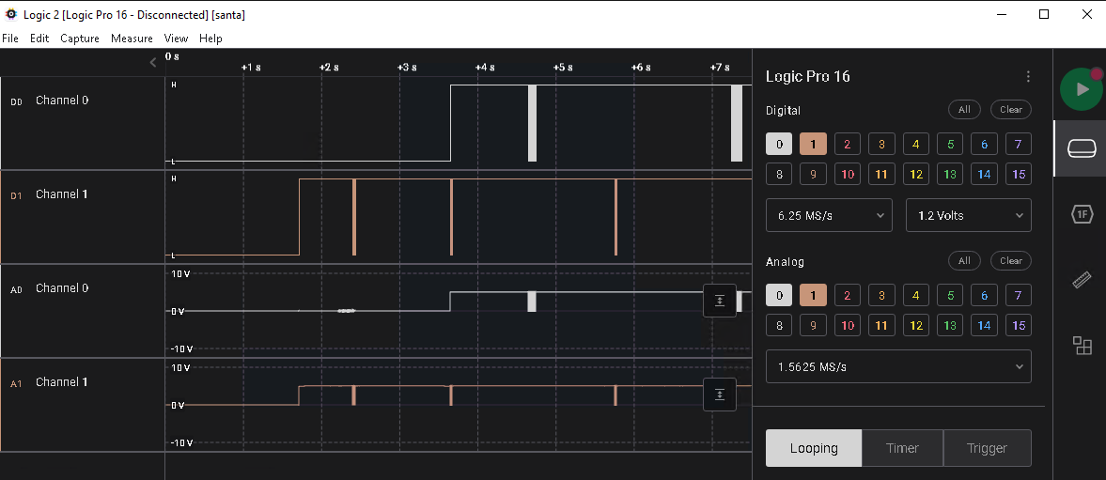

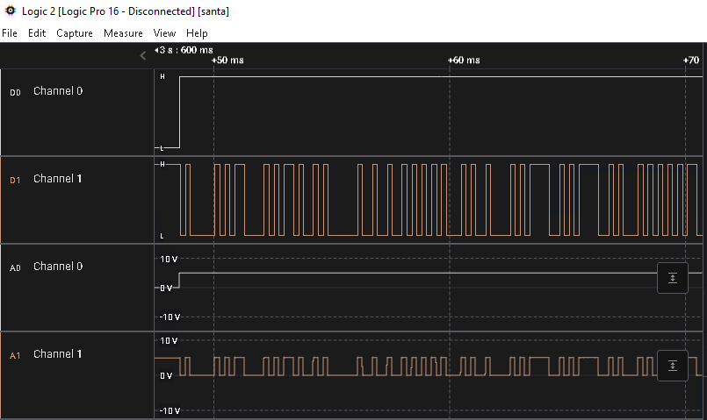

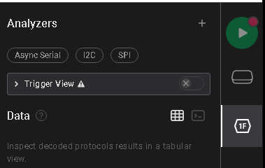

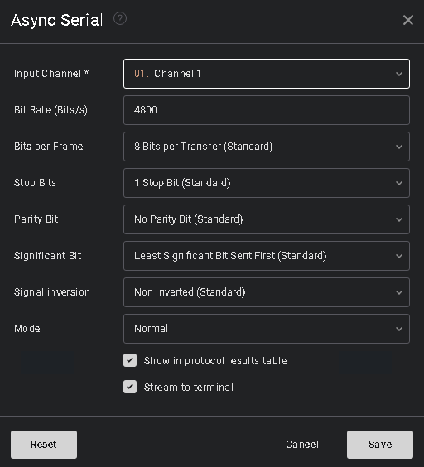

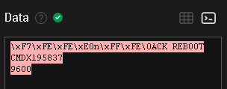

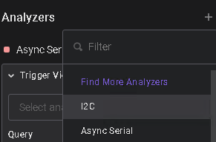

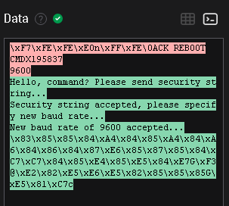

Top of Form

Bottom of Form

Top of Form

Bottom of Form

Top of Form

Bottom of Form

Top of Form

Bottom of Form

Top of Form

Bottom of Form

Top of Form

Bottom of Form

Top of Form

Bottom of Form

Top of Form

Bottom of Form

Top of Form

Bottom of Form

Top of Form

Bottom of Form

Task 25[Day 20] Firmware Binwalkin’ around the Christmas tree

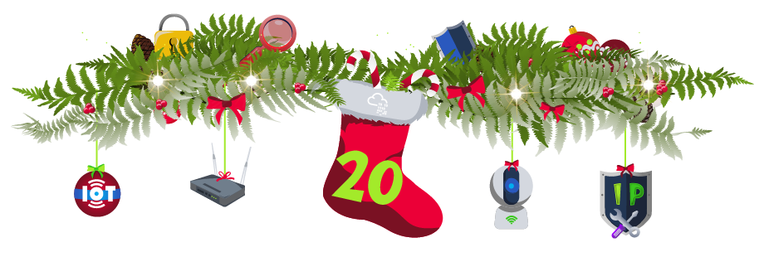

Top of Form

Bottom of Form

Top of Form

Bottom of Form

Top of Form

Bottom of Form

Top of Form

Bottom of Form

Task 26[Day 21] MQTT Have yourself a merry little webcam

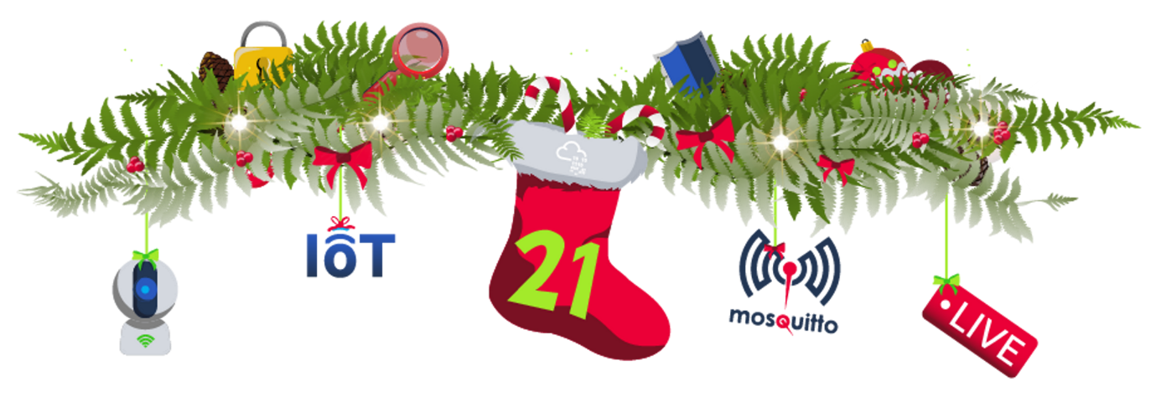



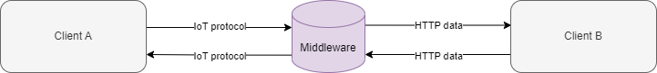

|  |  |  |
| --- | --- | --- |
|  |  |  |
|  |  |  |
|  |  |  |
|  |  |  |
|  |  |  |
|  |  |  |
|  |  |  |



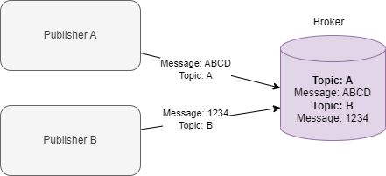

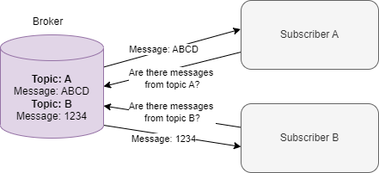





1. 

Top of Form

Bottom of Form

Top of Form

Bottom of Form

Top of Form

Bottom of Form

Top of Form

Bottom of Form

Top of Form

Bottom of Form

Task 27[Day 22] Attack Surface Reduction Threats are failing all around me

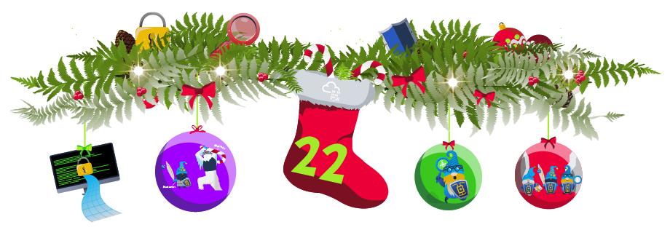

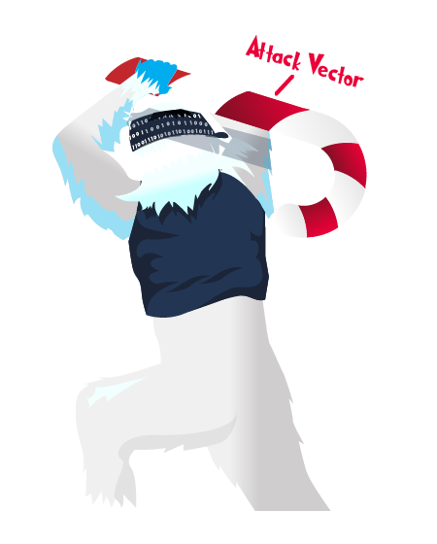

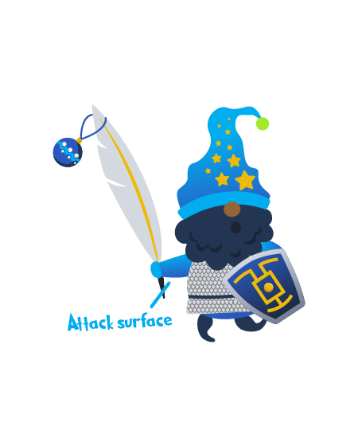

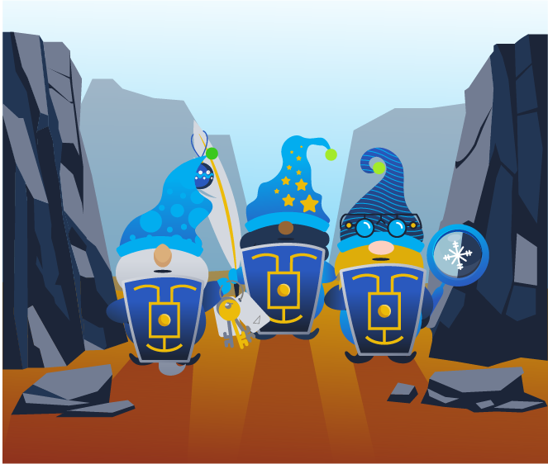

Top of Form

Bottom of Form

Top of Form

Bottom of Form

Task 28[Day 23] Defence in Depth Mission ELFPossible: Abominable for a Day

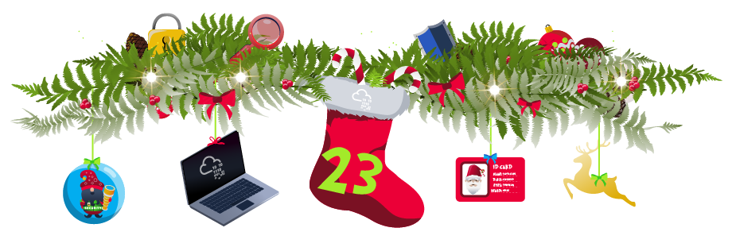





Top of Form

Bottom of Form

Top of Form

Bottom of Form

Top of Form

Bottom of Form

Top of Form

Bottom of Form

Top of Form

Bottom of Form

Top of Form

Bottom of Form

Top of Form

Bottom of Form

Top of Form

Bottom of Form

Top of Form

Bottom of Form

Top of Form

Bottom of Form

Top of Form

Bottom of Form

Top of Form

Bottom of Form

Top of Form

Bottom of Form

Top of Form

Bottom of Form

Top of Form

Bottom of Form

Task 29[Day 24] Feedback Ho, ho, ho, the survey's short



Top of Form

Bottom of Form

Top of Form

Bottom of Form

Top of Form

Bottom of Form

Task 30[Day 24] The EndThe Year of the Bandit Yeti